**PROJECT REPORT**

**ON**

**“Online Event Management”**

**Submitted To**



**C.B PATEL COMPUTER COLLEGE &**

**J. N. M. PATEL SCIENCE COLLEGE, SURAT**

**Affiliated To**

**VEER NARMAD SOUTH GUJARAT UNIVERSITY, SURAT**

**AS PARTIAL REQUIREMENT FOR THE DEGREE**

OF

**BACHELOR OF COMPUTER SCIENCE**

[B.C.A]

**ACADEMIC YEAR 2019-20**

|  |  |  |  |  |
| --- | --- | --- | --- | --- |
| **SUBMITTED BY:** |  |  | **GUIDED BY:** |  |
| **Dalal Harshil Rajubhai (Exam No: 1037)** | | **Asst. Prof. Mrs. Kirti Patel** | | |
| **Shah Velcy Hemantkumar (Exam No: 1180)** | |  |  |  |

**Acknowledgement**

It was highly eventful session at the B.C.A (Bachelor Of Computer Application), VNSGU; working with highly devoted computer teachers’ community and probably remain the most memorable experience. Hence, this acknowledgement is a humble attempt to thank all those who directly involved in our ‘Project Work’ and were of immense help us to successfully complete this project.

We greatly thank **Mr. Ketan Patel** for giving us this opportunity and support for developing the system.

We greatly thank **Mr. Ketan Patel** who built our foundation in ASP.NET and provide constant support and encouragement. Because of his guidance, we learn to work out on each and every small detail. We sincerely hope that this project would strive to answer the diverse need of the organization. The project indeed gave a challenging and exhilarating experience in designing and developing the required system.

We express a deep sense of gratitude to **Prof. Kirti Patel** for his valuable time and guidance regarding our project.

This acknowledgement is lifeless without expressing our heaty-felt gratitude to our **Parents & Friends** for being a constant source of inspiration & uncountable reasons . This project is a small tribute to their hopes & aspirations.

Dalal Harshil R.

Shah Velcy H.

**Preface**

It is a great pleasure for us as a student of **C.B.Patel Computer College** to prepare a project of **“Event Management”** for the partial fulfilment of the requirement of the degree of **B.C.A(Bachelor Of Computer Application)** from **Veer Narmad South Gujarat University(VNSGU) .**

As a student of Computer Field , we are encouraged by growth & rapid development in the software industries , keeping in mind that increase demand for software & software engineers the university has arranged project work for the third year .Thus it is our moral & obligatory duty to take this project as a part of our studies with the great enthusiasm & seriousness . For this we have gone through a development program of 3 months.

**Index**

|  |  |  |
| --- | --- | --- |
| Sr.No | Chapter Name | Page No |
| **1** | **Project Profile** | **5** |
| **2** | **Aims & Objective Of The Project** | **6** |
| **3** | **Project: Event Management** | **7** |
|  | 3.1 Introduction | **8** |
|  | 3.2 Scope | **9** |
|  | 3.3 Software requirement Specification | **10** |
| **4** | **Tools & Technology** | **12** |
|  | **4.1 Hardware & Software Requirement** | **12** |
|  | 4.1.1 Development Tools | **12** |
|  | 4.1.2 Client Side Tools | **13** |
|  | 4.1.3 Server Side Tools | **13** |
|  | **4.2 Tools & Technology Used** | **14** |
|  | 4.2.1 Core Technology | **14** |
|  | 4.2.2 Extra Tools | **15** |
| **5** | **Analysis Report** | **17** |
|  | 5.1 Current System | **18** |
|  | 5.2 Drawback Of Current System | **18** |
|  | 5.3 Requirement Specification | **19** |
|  | 5.4 Proposed System | **20** |
|  | 5.5 Data Flow Diagram | **21** |
|  | 5.6 UML Diagram | **36** |
|  | 5.7 ER Diagram | **38** |
|  | 5.8 Use Case Diagram | **39** |
|  | 5.9 Data Dictionary | **42** |
|  | 5.10 Flowchart | **48** |
|  | 5.11 Table Structure With Proper Relationship | **49** |
| **6** | **Design Report** | **57** |
|  | 6.1 Input Screen Layout | **57** |
|  | 6.2 Output Reports | **87** |
| **7** | **Testing Report** | **109** |
|  | 7.1 Unit Testing | **110** |
|  | 7.2 Integration Testing | **111** |
|  | 7.3 Validation Testing | **112** |
| **8** | **Limitation Of System** | **122** |
| **9** | **Future Enhancement** | **123** |
| **10** | **Conclusion** | **124** |
| **11** | **References** | **125** |

**1. Project Profile**



**Project Title** : Event Management

**Project Objective** : Online Event Booking

**Name of the Institute** : ItdotForce

**Name of College**  : C.B.Patel Computer College

**Duration** : 3 Months

**Front-End Tool** : ASP.NET

**Back-End Tool** : SQL

**Operating System** : Windows 10

**External Guide** : Mr. Ketan.A.Patel

**Internal Guide** : Mrs. Kirti Patel

**Submitted By** : Dalal Harshil Rajubhai

Shah Velcy Hemantkumar

**2. Aims & Objectives of the System**

* **Complete database management :**
* Database Security
* Effective database management
* Transaction management
* Maintain addition or deletion in any category
* **Web base system :**
* Easy and fast response
* Flexible to access
* provides details efficiently
* **Security management :**
* Session tracking
* **System should be error free :**
* Modification does not point to error
* **System should be user friendly :**
* User friendly interface
* Easy availablity of multiple category of books at one place at a same time.
* User and advertiser management.

**3. Event Management**

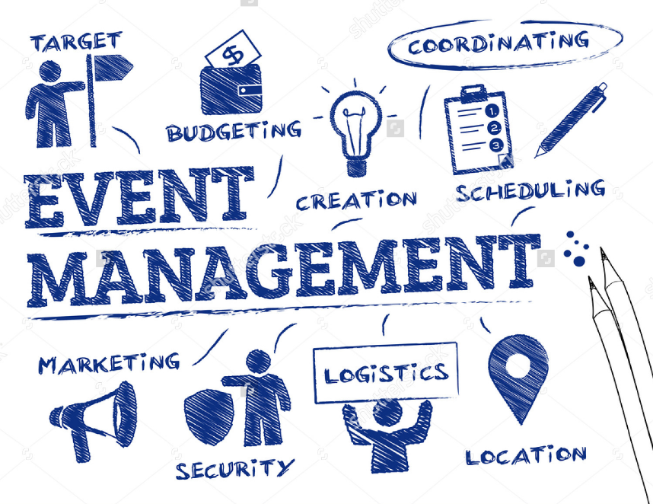

**3.1 Project Introduction**

**3.2 Scope**

**3.3 Software requirement specification**

**3.1 Project Introduction**

**Event management** is the application of project management to the creation and development of large-scale events such as festivals, conferences, ceremonies, weddings, formal parties, concerts, or conventions. It involves studying the brand, identifying its target audience, devising the event concept, and coordinating the technical aspects before actually launching the event.

The events industry now includes events of all sizes from the Olympics down to business breakfast meetings. Many industries, charitable organizations, and interest groups hold events in order to market their label, build business relationships, raise money, or celebrate achievement.

The process of planning and coordinating the event is usually referred to as **event planning** and which can include budgeting, scheduling, site selection, acquiring necessary permits, coordinating transportation and parking, arranging for speakers or entertainers, arranging decor, event security, catering, coordinating with third party vendors, and emergency plans. Each event is different in its nature so process of planning & execution of each event differs on basis of type of event.

The **event manager** is the person who plans and executes the event, taking responsibility for the creative, technical, and logistical elements. This includes overall event design, brand building, marketing and communication strategy, audio-visual production, script writing, logistics, budgeting, negotiation, and client service.

Due to the complexities involved, the extensive body of knowledge required, and the rapidly changing environment, event management is frequently cited as one of the most stressful career paths, in line next to emergency responders and surgeons.

**3.2 Scope**

The scope of the project is just limited to a laptop or a pc with an internet connection. Firstly the user, whoever it may be (student of faculty) need to register to the website. After the registration process is completed each one of them gets a password and have their own user ids. With these two they can access their account and for any query they can contact the administrator by sending him a mail.

* Facility to book an event as well as regarding its services
* Facility to vendor explore its business or services
* Facility to user can edit event schedule
* User registration
* User have privilage to edit user's profile

**3.3 Software Requirement Specification**

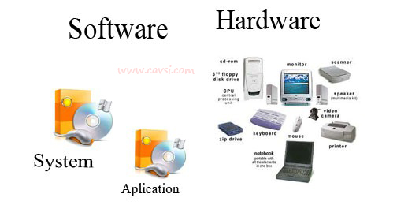

**Hardware & Software Requirements**

* Hardware Configuration :-

**Processor** : Intel I7 Processor

**Ram**  : 8GB Ram

**Hard Disk** : 1TB

**Input Device** : Keyboard, Mouse

**Output Device** : Monitor

**Required** : Internet Connection

* Software Configuration :-

**Operating System**  : Windows 10 (64 bits)

**Front-End** : ASP.NET

**Back-End**  : Sql

**Environment Used**

**Development** : Ms-word 2013(For Document)

**Tools**

**Client side tools**  : Google Chrome

Internet connection

(Wireless,Broadband,Wifi)

**4. Tools & Technology**



**4.1 Hardware & Software Requirement**

**4.1.1 Development Tools.**

**4.1.2 Client Side Tools.**

**4.1.3 Server Side Tools.**

**4.1.1** **Development Tools**

* ASP.NET C#
* Ms Office 2013 (for Report and Documentation)
* Edraw Max 8.4

**4.1.2 Client Side Tools**

* Mozilla Firefox, Google Chrome
* Internet Connection (Wireless, Broadband, Wi-Fi)

**4.1.3 Server side Tools**

* Intel I7
* 8GB RAM
* 1TB Hard Disk

**4.2 Tools & Technology Used**

**4.2.1 Core Technology**

* **Front - End Tools**
* **Asp.NET**
* ASP .net is pretty different in its own right. It’s kinda a hybrid, mostly designed for presentation and UI(frontend), but there are special controls and SQL functions that can actually reach the middle and backend I think. If you get into this world, it’s easier for me to remember that there’s also Cold Fusion, which is more of Microsoft’s version of java server pages , than asp .
* ASP .NET is a multipurpose web development framework. It can be used to build full-stack (front-end + back-end) applications (with MVC + Razor), front-end applications (using Blazor), and back-end applications (using MVC and Web API).
* **Back - End Tools**
* **SQL**
* SQL (Structure Query Language) is a back-end language, used with Relational Databases in database servers (typically referred to as RDBMS - Relational Database Management Systems), which typically power the back-ends for most client-server applications. Meaning the ‘back’ end is the database, and the ‘front’ end is what you see on the web page in the browser.

**4.2.2 Extra Tools**

* **Java Script**



Java script is the proto type based scripting language that is dynamic weakly typed and has first class function. It is a multi-paradigm language, supported object oriented, imperative and functional programming Style.

Java script was formalized in the ECSMAS Script language standard and in primary used in the form of client side java script implements as part of web browser in order to provide enhance used interface and dynamic website this enable programmatic access to the computational object within a host environment.

Java script is used in the application outside web pages for example in PDF documents, site Specific Browser and desktop Widgets is also significant Newer and faster JavaScript VM sand framework built upon then have also increased the popularity of JavaScript for server side web application.

* **JQuery**



Jquery is a cross browser JavaScript library deigned to simplify the client side scripting of HTML it was released in January 2006 at bar camp NYC but john Resign used by over 55% of the 10,000 most visited website, Jquery is he most popular JavaScript library in used today.

JQuery is free open source software, dual licensed under the MIT license or the GNU general public license version 2. JQuery syntax is design to make it easier to navigate a document, select DOM element, create animation, handle events, and develop Ajax application. JQuery also provides capabilities for developer to create plug-ins on top of the Javascript library. This enables developers to create abstraction for low level interaction and animation, advanced effects and high-level, theme-able widgets. The modular approach to the JQuery library allows the creation of powerful dynamic web pages and web application.

Microsoft and Nokia have announced plans to bundle JQuery on their platforms. PHP AJAX framework and PHP MVC framework while Nokia has integrated it into their Web Run-Time widget development platforms. JQuery has also been used in Media Wiki since version 1.1.

**5. Analysis Report**

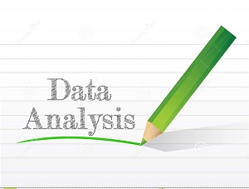

**5.1 Current System**

**5.2 Drawback of Current System**

**5.3 Requirement Specification**

**5.4 Proposed System**

**5.5 Data Flow Diagram**

**5.6 UML Diagram**

**5.7 ER Diagram**

**5.8 Use Case Diagram**

**5.9 Data Dictionary**

**5.10 Flowchart**

**5.11 Table Structure with Proper Relationship**

**5.1 Current System**

In existing system there are lot of paper work and manual processing.

While writing a paper records the management have to keep the records very carefully as the entire data is written in those books.

Everything is paper based hence it is very time consuming.

More than one person cannot access the data at same time.

**5.2 Drawback Of Current System**

* It is a very demanding and stressful job which requires you to be on your toes 24x7
* The deadlines and targets are too specific and difficult to catch up on with.
* It requires constant learning and keeping yourself up to date with the latest tools and techniques in the market.
* The work schedule is not fixed in such job profiles and requires you to be flexible in terms of timings.
* It requires you to be someone who is budget-friendly and can handle the financial aspect very well.

**5.3 Requirement Specification**

* Hardware Configuration :-

**Processor** : Intel I7 Processor

**Ram**  : 8GB Ram

**Hard Disk** : 1TB

**Input Device** : Keyboard, Mouse

**Output Device** : Monitor

**Required** : Internet Connection

* Software Configuration :-

**Operating System**  : Windows 10 (64 bits)

**Front-End** : ASP.NET

**Back-End**  : Sql

**Environment Used**

**Development** : Ms-word 2013(For Document)

**Tools**

**Client side tools**  : Google Chrome

Internet connection

(Wireless, Broadband ,Wi-Fi)

**5.4 Proposed System**

* Web based
* Eliminate paper work
* Map Facility
* Reduce Manual Processing
* Economical in the long run
* Increases Management Productivity

**5.5 Data Flow Diagram**

Data flow diagrams (DFD) was first developed by LARRY CONSTANTINE as way representing system requirements in a graphical form; this lead to modular design. A DFD describes what data flow (logical) rather than how they are processed, so it does not depend on hardware, software, data structure or file organization. It is also known as ‘bubble chart’.

A Data Flow Diagrams is a structured analysis and design tool that can be used for flowcharting in place of, or in association with, information-oriented and process-oriented systems flowcharts. A DFD is a network that describes the flow of data and the processes that change, or transform, data throughout a system. This network is constructed by using a set of symbols that do not imply a physical implementation. It has the purpose of clarifying system requirements and identifying major transformations that will become programs in system design. So it is the starting point of the design phase that functionality decomposes the requirement specifications down to the lowest level of detail.

The symbols used to prepare DFD do not imply a physical implementation, a DFD can be considered to an abstract of the logic of an information-oriented or a process-oriented system flow-chart. For these reasons DFDs are often referred to as logical data flow diagrams. The four basic symbols used to construct data flow diagrams are shown below:

1. A rectangle represents a data source or destination.
2. A directed line represents the flow of data that is data stream.
3. An enclosed figure, usually a circle or an oval bubble, represents a process that transforms data streams.
4. An open-ended rectangle represents data storage.

These are symbols that represent data flows, data sources, data transformations and data storage. The points at which data are transformed are represented by enclosed figures, usually circles, which are called nodes. The principle processes that take place at nodes are:

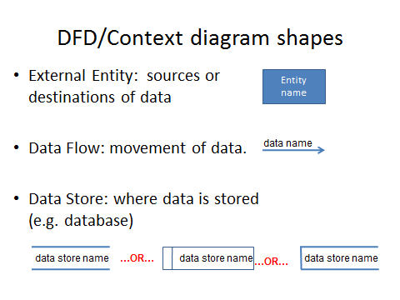

**Zero Level**

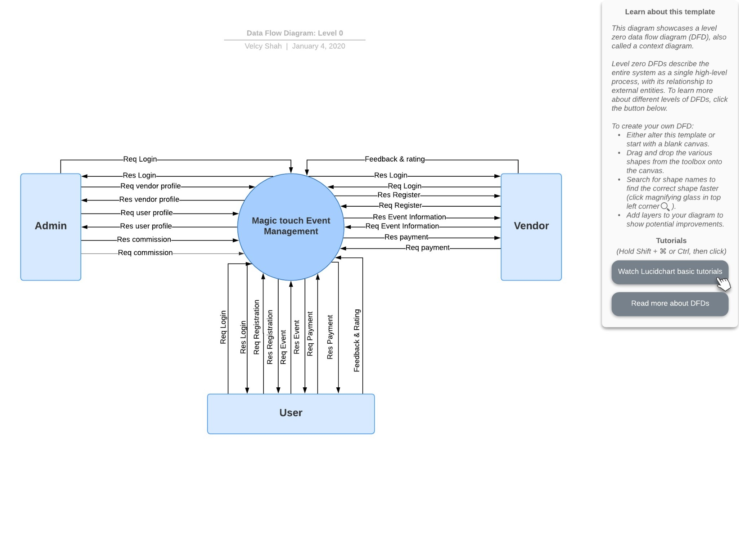

**First Level Of Admin**

Login

City

User

Vendor

Event Type

Vendor

Review

Vendor Rate

Admin

tblLogin

Admin Login

Admin Login

Manage City

Manage City

tblCity

Manage User

Manage User

tblUser

Manage Vendor

Manage Vendor

tblVendor

Manage Event Type

Manage Event Type

tblEventType

View Vendor Review

View Vendor Review

tblVendorReview

View Vendor Rate

View Vendor Rate

tblVendorRate

1.1

1.2

1.3

1.4

1.5

1.6

1.7

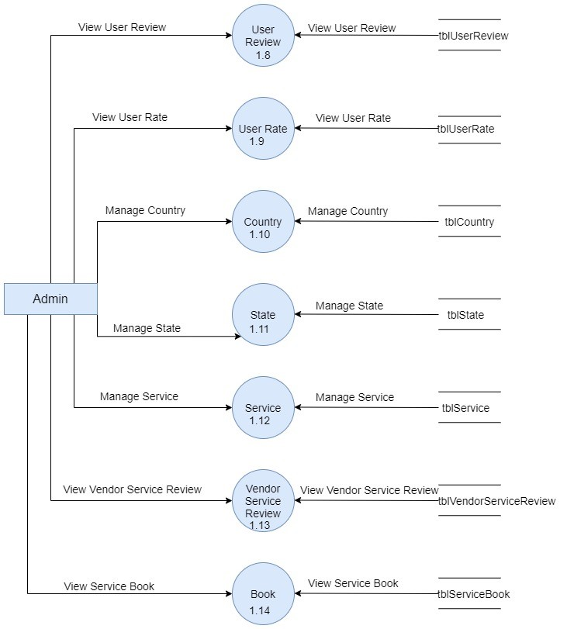

**First Level Of Vendor**

Registration

Login

Service

Vendor

Service

Book

**Vendor**

2.1

2.2

2.3

2.4

2.5

Vendor Registration

Vendor Registration

Vendor Login

Vendor Login

View Service

View Service

Manage Vendor Services

Manage Vendor Services

Manage Book

Manage Book

tblVendor

tblService

tblVendor

tblVendorService

tblBook

**First Level Of User**

Register

Login

Country

State

City

Event

Event Type

Vendor

Service

**User**

3.1

3.2

3.3

3.4

3.6

3.7

3.8

3.5

tblUser

tblUser

tblCountry

tblState

tblCity

tblEvent

tblEventType

tblVendorService

User Registration

User Registration

User Login

User Login

Select Country

Select Country

Select State

Select State

Select City

Select City

Manage Event Details

Manage Event Details

Select Event Type

Select Event Type

Select Vendor Service

Select Vendor Service

**Second Level Of Login Process**

1.1

Generate Login Info

1.2

Password

1.3

varify Login Info

Req_Login_Info

Req_Login_Info

Res_Login_Info

Res_Login_Info

tblLogin

Req_Varify_Info

Res_Varify_Info

**Second Level Of City Management**

2.1

Select City

2.1.1

Insert

2.1.2

Update

2.1.3

Delete

tblCity

2.2

Display

Res_Insert

Req_Insert

Res_Delete

Req_Delete

Res_Update

Req_Update

Res_Details

Req_Details

Req_Display

Res_Display

Res_Display

Req_Display

Res_Display

Req_Display

**Second Level Of Vendor Management**

3.1

Manage

Vendor

3.1.1

Delete

tblVendor

3.2

Display

Req_Delete

Res_Delete

Req_Details

Res_Details

Res_Display

Req_Display

**Second Level Of EventType Management**

4.1

Select

EventType

4.1.1

Insert

4.1.2

Update

4.1.3

Delete

tblEventType

4.2

Display

Res_Insert

Req_Insert

Res_Delete

Req_Delete

Res_Update

Req_Update

Res_Details

Req_Details

Req_Display

Res_Display

Res_Display

Req_Display

Res_Display

Req_Display

**Second Level Of Country Management**

5.1

Select

Country

5.1.1

Insert

5.1.2

Update

5.1.3

Delete

tblCountry

5.2

Display

Res_Insert

Req_Insert

Res_Delete

Req_Delete

Res_Update

Req_Update

Res_Details

Req_Details

Req_Display

Res_Display

Res_Display

Req_Display

Res_Display

Req_Display

**Second Level Of State Management**

6.1

Select State

6.1.1

Insert

6.1.2

Update

6.1.3

Delete

tblState

6.2

Display

Res_Insert

Req_Insert

Res_Delete

Req_Delete

Res_Update

Req_Update

Res_Details

Req_Details

Req_Display

Res_Display

Res_Display

Req_Display

Res_Display

Req_Display

**Second Level Of Service Management**

7.1

Manage

Service

7.1.1

Insert

7.1.2

Update

7.1.3

Delete

tblService

7.2

Display

Res_Insert

Req_Insert

Res_Delete

Req_Delete

Res_Update

Req_Update

Res_Details

Req_Details

Req_Display

Res_Display

Res_Display

Req_Display

Res_Display

Req_Display

**Second Level Of Vendor Service Management**

8.1

Select Vendor

Service

8.1.1

Insert

8.1.2

Update

8.1.3

Delete

tblVendorService

8.2

Display

Res_Insert

Req_Insert

Res_Delete

Req_Delete

Res_Update

Req_Update

Res_Details

Req_Details

Req_Display

Res_Display

Res_Display

Req_Display

Res_Display

Req_Display

**5.6 UML Diagram**

* The **Unified Modeling Language** (UML) is a standard  language for specifying, visualizing, constructing, and documenting the artifacts of software systems, as well as for business modeling and other non-software systems.
* The UML is a very important part of developing objects oriented software and the software development process.
* Using the UML helps project teams communicate, explore potential designs, and validate the architectural design of the software.
* The **primary goals** in the design of the UML were:
* Provide users with a ready-to-use, expressive visual modeling language so they can develop and exchange meaningful models.
* Provide extensibility and specialization mechanisms to extend the core concepts.
* Be independent of particular programming languages and development processes.
* Integrate best practices

.

* **Why Use UML?**
* In particular, they recognize the need to solve recurring architectural problems, such as physical distribution, concurrency, replication, security, load balancing and fault tolerance. Additionally, the development for the World Wide Web, while making some things simpler, has exacerbated these architectural problems. The Unified Modeling Language (UML) was designed to respond to these needs.
* **Types of UML Diagrams**
* Use case Diagram
* Activity Diagram
* **Use Case Diagram :**
* A use case diagram in the UML is a type of behavioural diagram defined by and created from a Use-case analysis. ...
* A use case diagram is a UML diagram that provides a high-level graphical view of the functionality (use cases) supported by the system and shows which roles (actors) can invoke each use case. ...
* Displays the relationship among actors and use cases. Class Diagram models class structure and contents using design elements such as classes, packages and objects. It also displays relationships such as containment, inheritance, associations and others.
* A diagram to show the various user roles and how those roles use the system. Here we use four roles of user in our website. Here we use four roles of user in our website.
* **Four Actors in Our Website:**
  + - **Admin**(Admin who manage to all admin)
    - **Lawyer(**Who is register lawyer of website)
    - **Client(**Who is register client of website)
    - **Visitor(**Who is not registered user)

**5.7 ER Diagram**

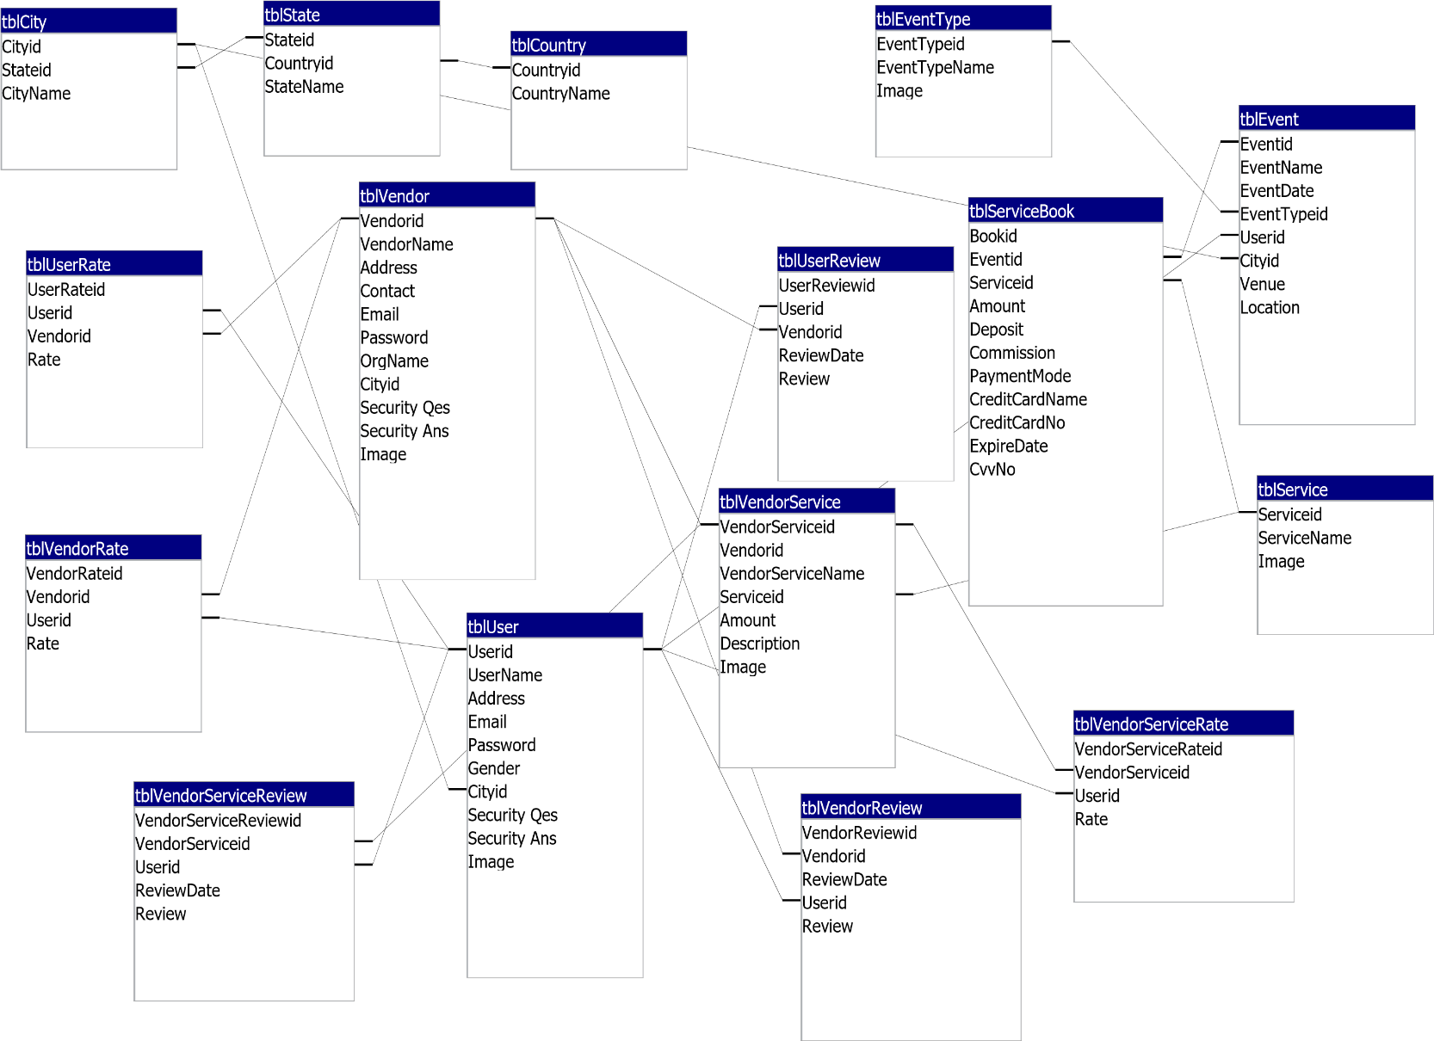

**5.8 Use Case Diagram**

* **Use Case For Admin**

Login

View Vendors

View Users

Manage

Country,State,City

Manage EventType

Log Out

**Admin**

Change Password

View Service

View Vendor Service

View Rate & Reviews

* **Use Case For Vendor**

Ragistration

Forgot Password

Login

Change Password

Manage Profile

Manage Vendor Service

**Vendor**

View Booking

Confirm Booking

Give ReviewRate to User

Log Out

* **Use Case For User**

Ragister

Forget Password

Login

Manage Profile

Change Password

Manage Event Details

**User**

Book Event

Make Payment

Review & Rating

Log Out

**5.9 Data Dictionary**

**Login**

|  |  |
| --- | --- |
| Name | Login |
| Alias Name | L |
| Source | Web-User / Vendor / Admin |
| Destination | tblUserRegistration , tblVendorRegistration , tblAdmin |
| Description | Web-user , Vendor And Admin Can Login With Your Valid User ID And Password And Redirect In Your Profile. |

**Registration**

|  |  |
| --- | --- |
| Name | Registration |
| Alias Name | R |
| Source | Visitor / Vendor |
| Destination | tblUserRegistration , tblVendorRegistration |
| Description | Any New Visitor Can Fill Registration Form And Become Member. |

**City**

|  |  |
| --- | --- |
| Name | City |
| Alias Name | Ci |
| Source | Web-User / Vendor / Admin |
| Destination | tblCity |
| Description | Whenever user is Registered at that time user can see the City and Admin is managed the City. |

**Vendor**

|  |  |
| --- | --- |
| Name | Vendor |
| Alias Name | V |
| Source | Web-User / Vendor / Admin |
| Destination | tblVendor |
| Description | Whenever vendor is Registered at that time vendor can see the vendor’s data as well as manage its services. |

**EventType**

|  |  |
| --- | --- |
| Name | EventType |
| Alias Name | ET |
| Source | Admin |
| Destination | tblEventType |
| Description | Whenever admin is Registered at that time admin can manage the Event Type data as well as see Event Type and user can use that Event Type. |

**Country**

|  |  |
| --- | --- |
| Name | Country |
| Alias Name | Co |
| Source | Web-User / Vendor / Admin |
| Destination | tblCountry |
| Description | Whenever user is Registered at that time user can see the Country and Admin is managed the Country. |

**State**

|  |  |
| --- | --- |
| Name | State |
| Alias Name | S |
| Source | Admin |
| Destination | tblState |
| Description | Whenever user is Registered at that time user can see the State and Admin is managed the State. |

**Service**

|  |  |
| --- | --- |
| Name | Service |
| Alias Name | Se |
| Source | Admin |
| Destination | tblService |
| Description | Whenever user is Registered at that time user can use the services and Admin is managed the service. |

**VendorService**

|  |  |
| --- | --- |
| Name | VendorService |
| Alias Name | VS |
| Source | Vendor |
| Destination | tblVendorService |
| Description | Whenever user is Registered at that time user can use the services and Vendor is managed the Vendor service. |

**ServiceBook**

|  |  |
| --- | --- |
| Name | ServiceBook |
| Alias Name | SB |
| Source | User |
| Destination | tblServiceBook |
| Description | If User is Registered then User can Book the vendor services. That all book vendor services are stored into this table. |

**VendorRating**

|  |  |
| --- | --- |
| Name | VendorRating |
| Alias Name | VR |
| Source | Web-User / Admin |
| Destination | tblVendorRating |
| Description | Whenever Web-user are gives rating to Vendor that all are stored in this table. |

**UserRating**

|  |  |
| --- | --- |
| Name | UserRating |
| Alias Name | UR |
| Source | Web-User / Visitor |
| Destination | UserRating |
| Description | Whenever Vendors are gives rating to User that all are stored in this table. |

**VendorReview**

|  |  |
| --- | --- |
| Name | VendorReview |
| Alias Name | VRE |
| Source | Web-User / Admin / Visitor |
| Destination | VendorReview |
| Description | All Review which is Given by User that are stored in the table. Admin and User as well as Vendor can also see the Review that is Given by Web-user. |

**VendorServiceReview**

|  |  |
| --- | --- |
| Name | VendorServiceReview |
| Alias Name | VSR |
| Source | Web-User / Admin / Visitor |
| Destination | VendorServiceReview |
| Description | All Review which is Given by User that are stored in the table. Admin and User as well as Vendor can also see the Review that is Given by Web-user. |

**UserReview**

|  |  |
| --- | --- |
| Name | UserReview |
| Alias Name | UR |
| Source | Web-User / Admin / Visitor |
| Destination | UserReview |
| Description | All Review which is Given by Vendor that are stored in the table. Admin and User as wel as Vendor can also see the Review that is Given by Web-Vendor. |

**ContactUs**

|  |  |
| --- | --- |
| Name | ContactUs |
| Alias Name | Con |
| Source | User |
| Destination | ContactUs |
| Description | Web-users are contact our site that all contact are stored in this table. |

**Message**

|  |  |
| --- | --- |
| Name | Message |
| Alias Name | Me |
| Source | User / Vendor |
| Destination | Message |
| Description | Web-users and Vendor are communicate to each other, data are stored in this table. |

**5.10 Flowchart**

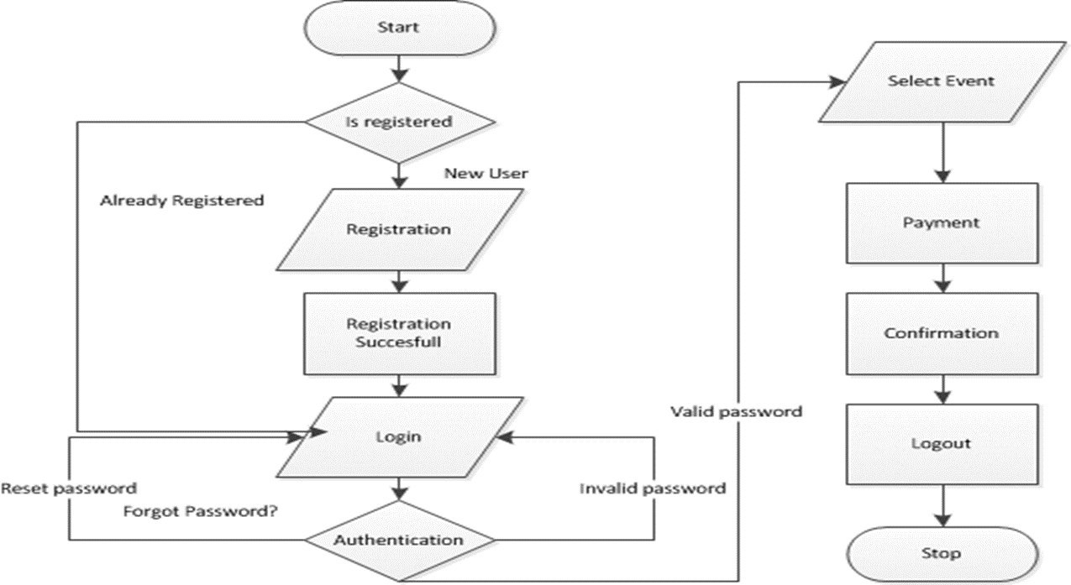

**5.11 Tables Details**

|  |  |  |
| --- | --- | --- |
| **tblAdmin** | | |
| **FieldName** | **Data Type** | **Key** |
| AdminName | Varchar |  |
| Password | Varchar |  |

|  |  |  |
| --- | --- | --- |
| **tblVendor** | | |
| **FieldName** | **Data Type** | **Key** |
| Vendorid | Numeric | PK |
| VendorName | Varchar |  |
| Address | Varchar |  |
| Contact | Varchar |  |
| Email | Varchar |  |
| Password | Varchar |  |
| OrgName | Varchar |  |
| Cityid | Numeric | FK |
| Security Qes | Varchar |  |
| Security Ans | Varchar |  |
| Image | Varchar |  |

|  |  |  |
| --- | --- | --- |
| **tblUser** | | |
| **FieldName** | **Data Type** | **Key** |
| Userid | Numeric | PK |
| UserName | Varchar |  |
| Address | Varchar |  |
| Contact | Varchar |  |
| Email | Varchar |  |
| Password | Varchar |  |
| Gender | Varchar |  |
| Cityid | Numeric | FK |
| Security Qes | Varchar |  |
| Security Ans | Varchar |  |
| Image | Varchar |  |

|  |  |  |
| --- | --- | --- |
| **tblEventType** | | |
| **FieldName** | **Data Type** | **Key** |
| EventTypeid | Numeric | PK |
| EventTypeName | Varchar |  |
| Image | Varchar |  |

|  |  |  |
| --- | --- | --- |
| **tblEvent** | | |
| **FieldName** | **Data Type** | **Key** |
| Eventid | Numeric | PK |
| EventName | Varchar |  |
| EventDate | Varchar |  |
| EventTypeid | Numeric | FK |
| Userid | Numeric | FK |
| Cityid | Numeric | FK |
| Venue | Varchar |  |
| Location | Varchar |  |

|  |  |  |
| --- | --- | --- |
| **tblCountry** | | |
| **FieldName** | **Data Type** | **Key** |
| Countryid | Numeric | PK |
| CountryName | Varchar |  |

|  |  |  |
| --- | --- | --- |
| **tblState** | | |
| **FieldName** | **Data Type** | **Key** |
| Stateid | Numeric | PK |
| Countryid | Numeric | FK |
| StateName | Varchar |  |

|  |  |  |
| --- | --- | --- |
| **tblCity** | | |
| **FieldName** | **Data Type** | **Key** |
| Cityid | Numeric | PK |
| Stateid | Numeric | FK |
| CityName | Varchar |  |

|  |  |  |
| --- | --- | --- |
| **tblVendorService** | | |
| **FieldName** | **Data Type** | **Key** |
| VendorServiceid | Numeric | PK |
| Vendorid | Numeric | FK |
| VendorServiceName | Varchar |  |
| Serviceid | Numeric | FK |
| Amount | Numeric |  |
| Description | Varchar |  |
| Image | Varchar |  |

|  |  |  |
| --- | --- | --- |
| **tblService** | | |
| **FieldName** | **Data Type** | **Key** |
| Serviceid | Numeric | PK |
| ServiceName | Varchar |  |
| Image | Varchar |  |

|  |  |  |
| --- | --- | --- |
| **tblVendorReview** | | |
| **FieldName** | **Data Type** | **Key** |
| VendorReviewid | Numeric | PK |
| Vendorid | Numeric | FK |
| ReviewDate | Varchar |  |
| Userid | Numeric | FK |
| Review | Varchar |  |

|  |  |  |
| --- | --- | --- |
| **tblVendorServiceReview** | | |
| **FieldName** | **Data Type** | **Key** |
| VendorServiceReviewid | Numeric | PK |
| VendorServiceid | Numeric | FK |
| Userid | Numeric | FK |
| ReviewDate | Varchar |  |
| Review | Varchar |  |

|  |  |  |
| --- | --- | --- |
| **tblVendorRate** | | |
| **FieldName** | **Data Type** | **Key** |
| VendorRateid | Numeric | PK |
| Vendorid | Numeric | FK |
| Userid | Numeric | FK |
| Rate | Numeric |  |

|  |  |  |
| --- | --- | --- |
| **tblVendorServiceRate** | | |
| **FieldName** | **Data Type** | **Key** |
| VendorServiceRateid | Numeric | PK |
| VendorServiceid | Numeric | FK |
| Userid | Numeric | FK |
| Rate | Numeric |  |

|  |  |  |
| --- | --- | --- |
| **tblUserReview** | | |
| **FieldName** | **Data Type** | **Key** |
| UserReviewid | Numeric | PK |
| Userid | Numeric | FK |
| Vendorid | Numeric | FK |
| ReviewDate | Varchar |  |
| Review | Varchar |  |

|  |  |  |
| --- | --- | --- |
| **tblUserRate** | | |
| **FieldName** | **Data Type** | **Key** |
| UserRateid | Numeric | PK |
| Userid | Numeric | FK |
| Vendorid | Numeric | FK |
| Rate | Numeric |  |

|  |  |  |
| --- | --- | --- |
| **tblServiceBook** | | |
| **FieldName** | **Data Type** | **Key** |
| Bookid | Numeric | PK |
| Eventid | Numeric | FK |
| VendorServiceid | Numeric | FK |
| Amount | Numeric |  |
| Deposit | Numeric |  |
| Commission | Numeric |  |
| PaymentMode | Numeric |  |
| CreditCardName | Varchar |  |
| CreditCardNo | Numeric |  |
| ExpireDate | Varchar |  |
| CvvNo | Numeric |  |

|  |  |  |
| --- | --- | --- |
| **tblMessage** | | |
| **FieldName** | **Data Type** | **Key** |
| Userid | Numeric |  |
| Vendorid | Numeric |  |
| Message | Varchar |  |
| Date | Varchar |  |
| Type | Varchar |  |

|  |  |  |
| --- | --- | --- |
| **tblContactUs** | | |
| **FieldName** | **Data Type** | **Key** |
| Contactid | Numeric | PK |
| Name | Varchar |  |
| Email | Varchar |  |
| ContactNo | Varchar |  |
| Description | Varchar |  |

**6. Design Report**

**6.1 Input Screen Layout**

* **Admin Side**
* **Admin Login**

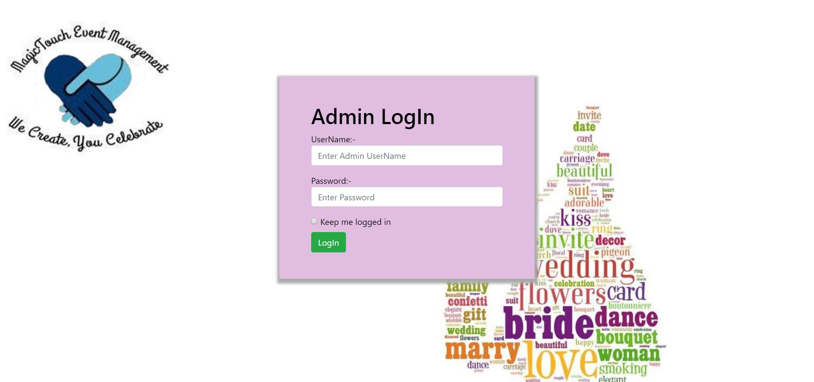

* **Change Password**

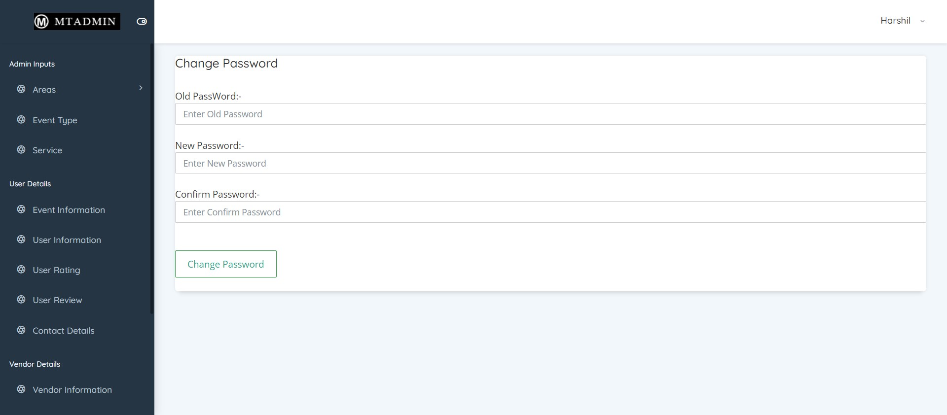

* **Event Type**

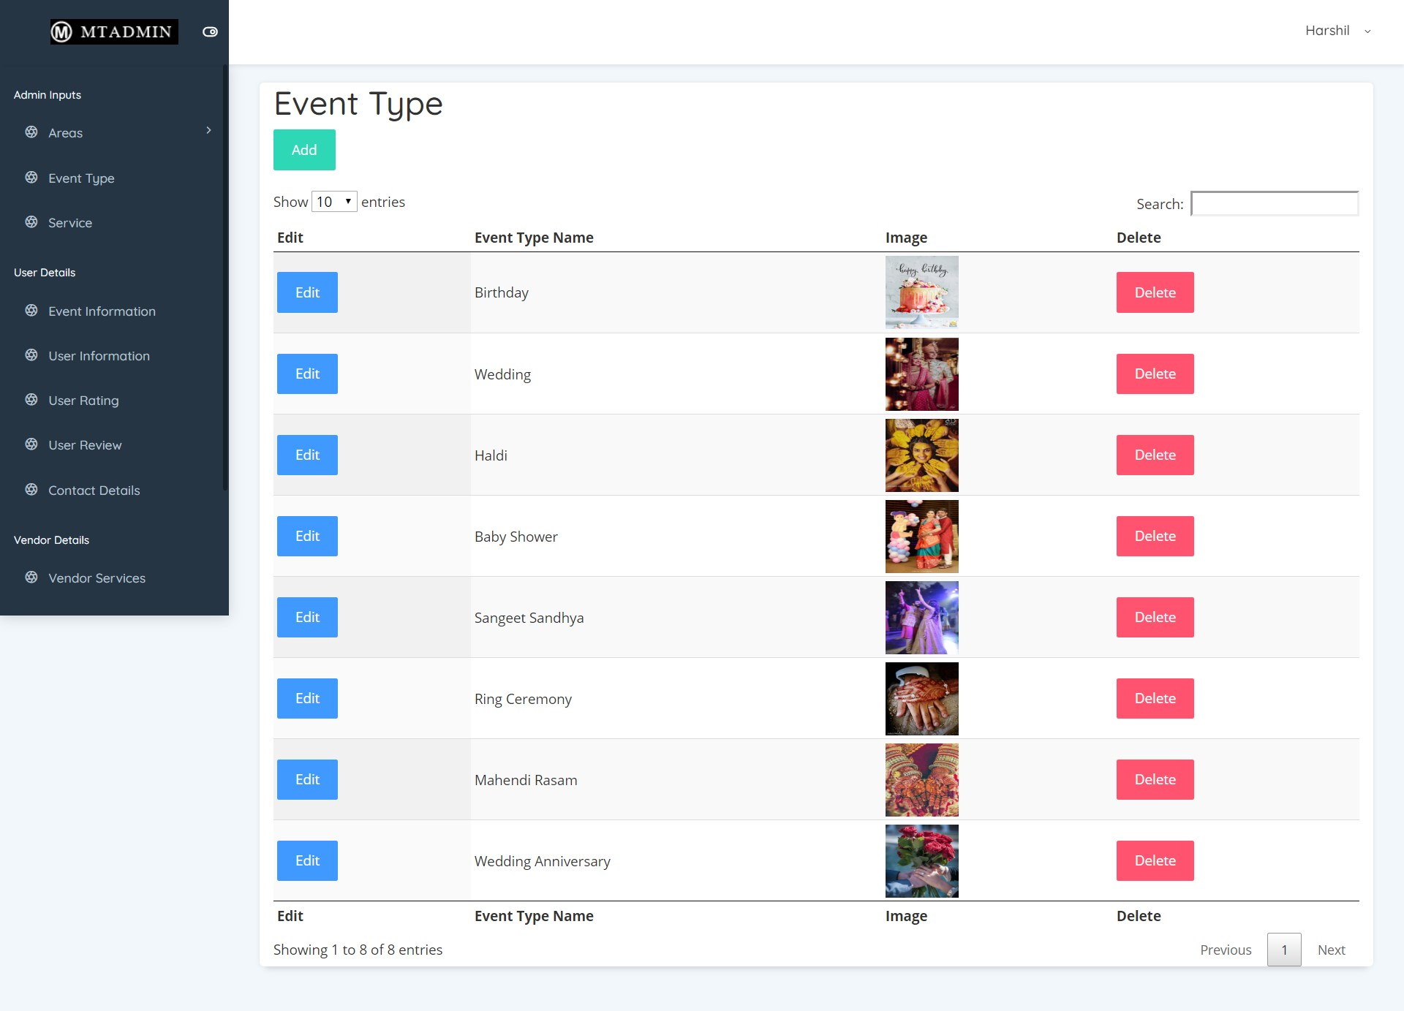

* **Service Details**

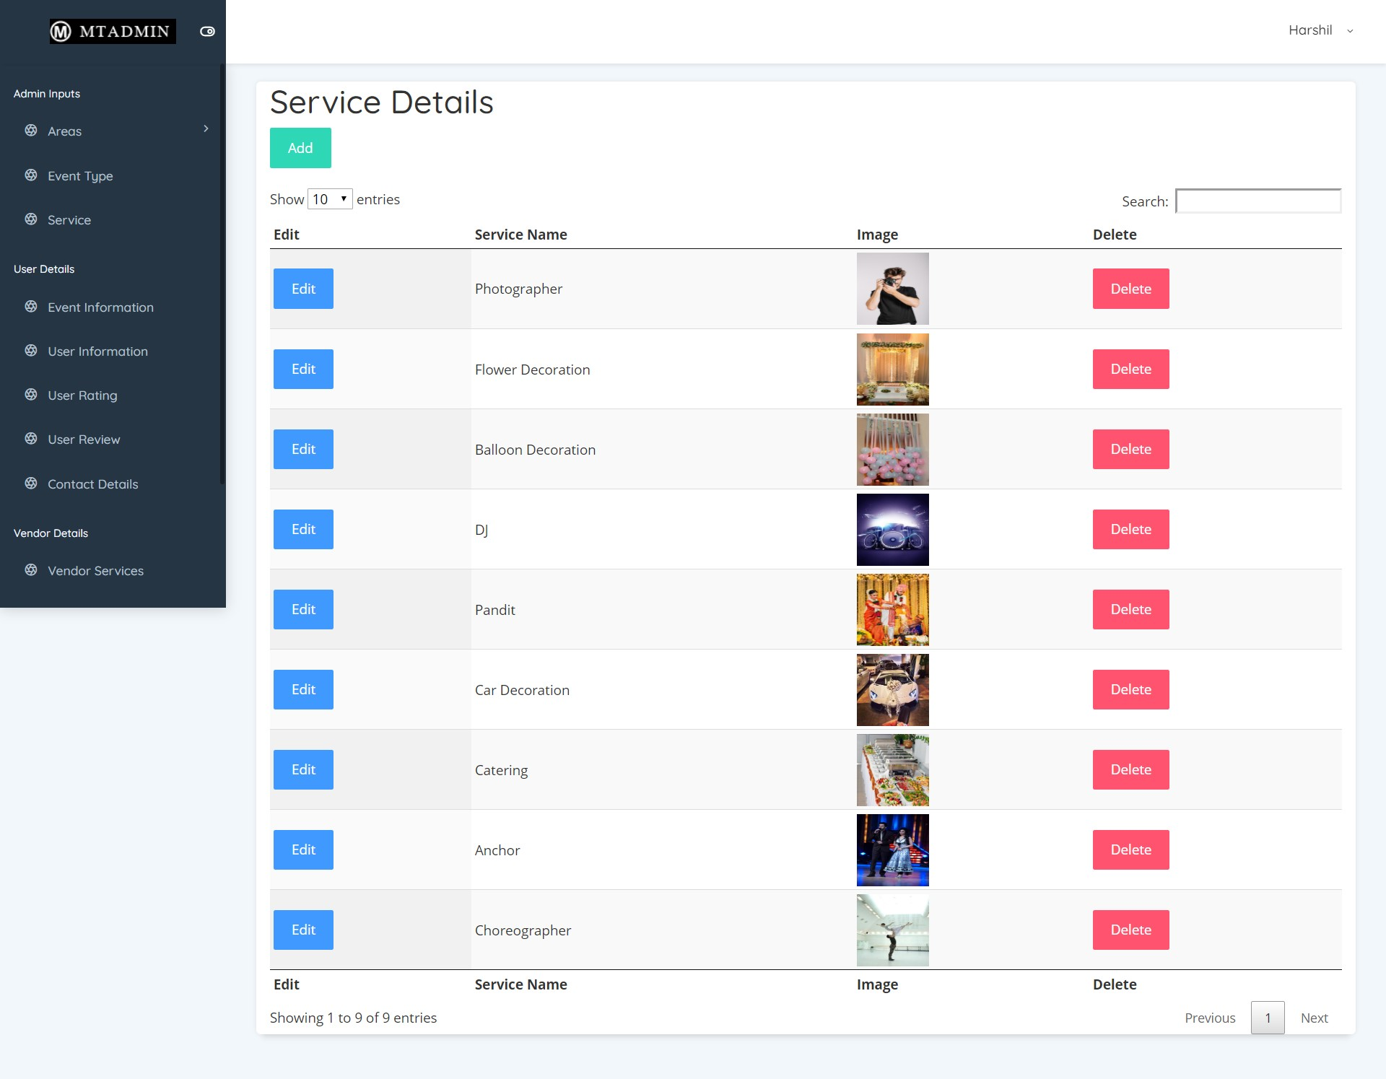

* **User Details**

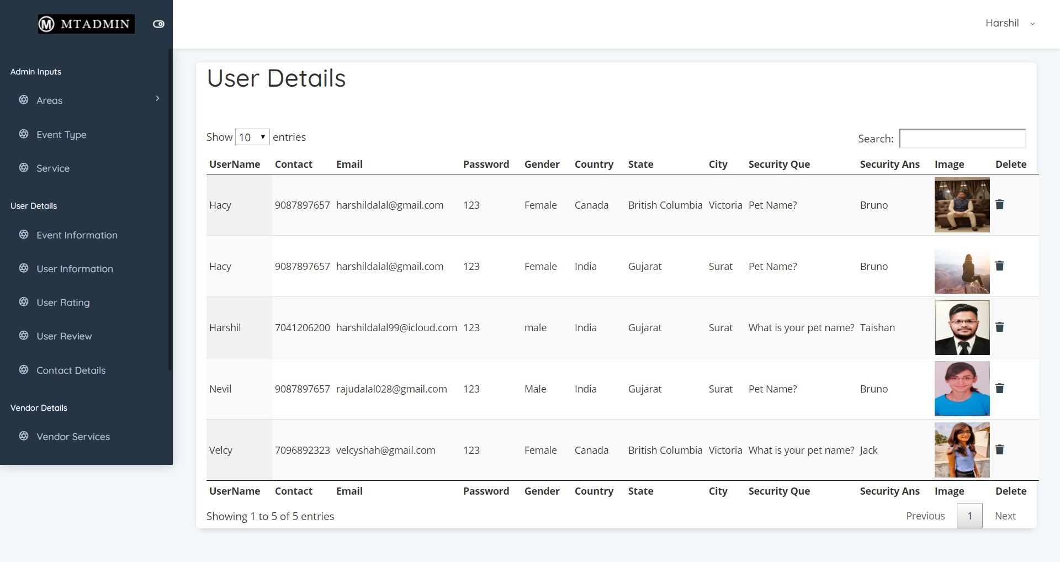

* **Event Details**

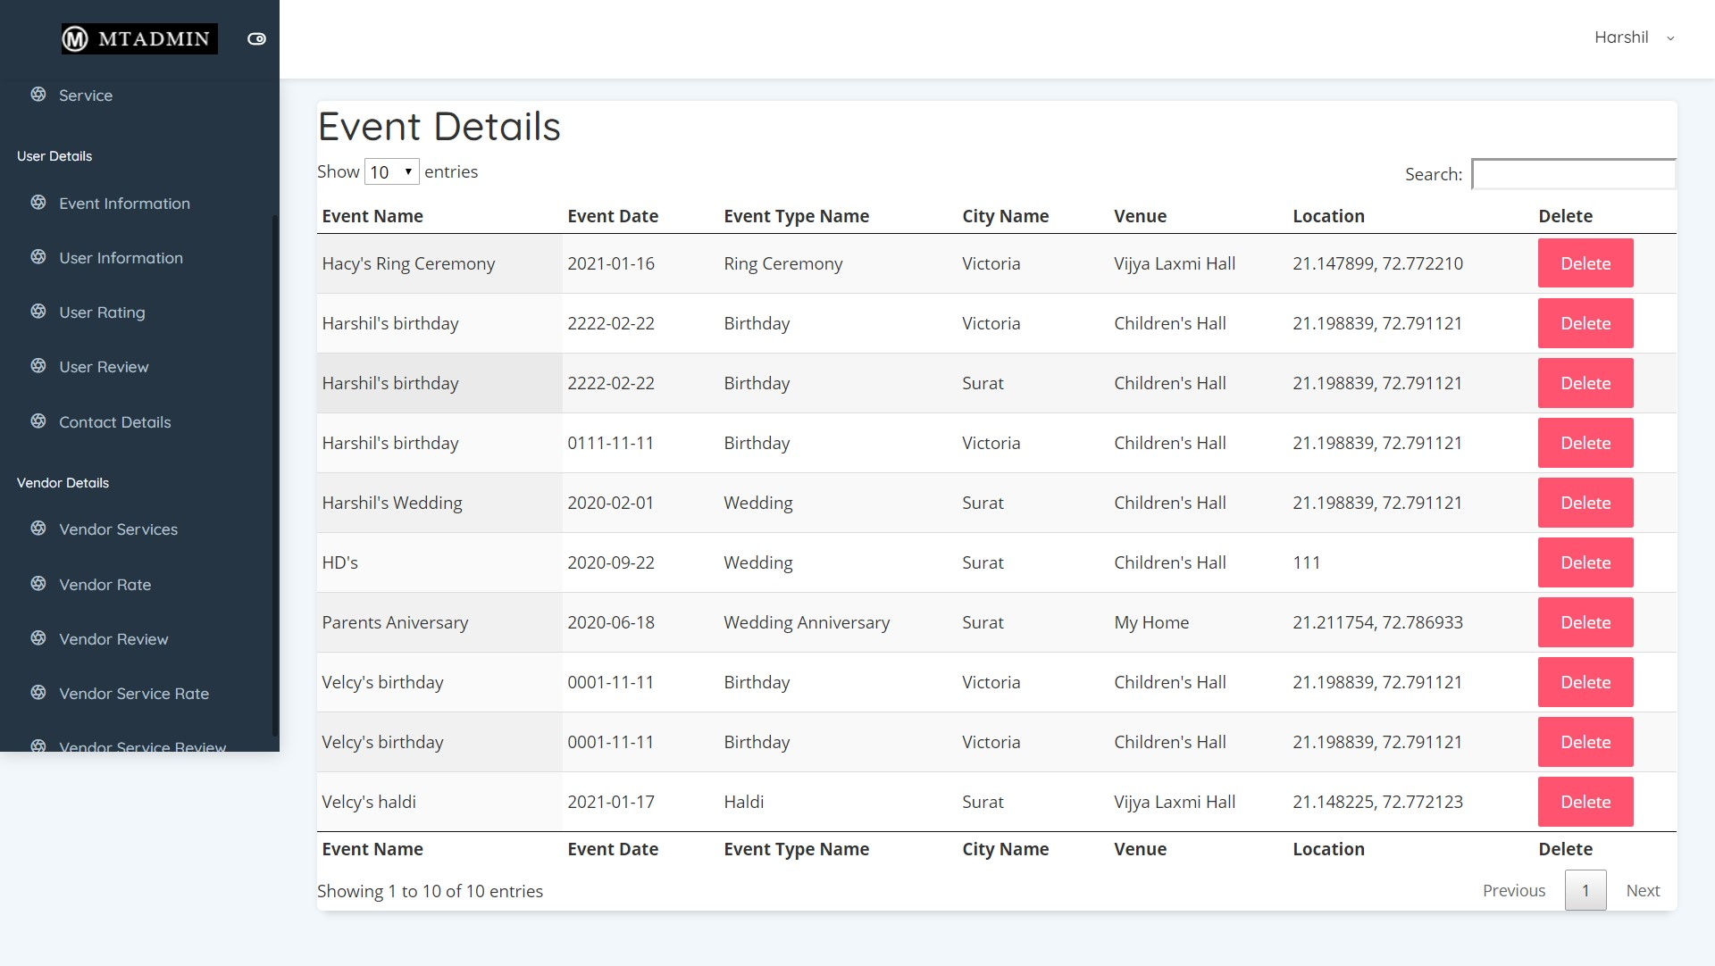

* **City Details**

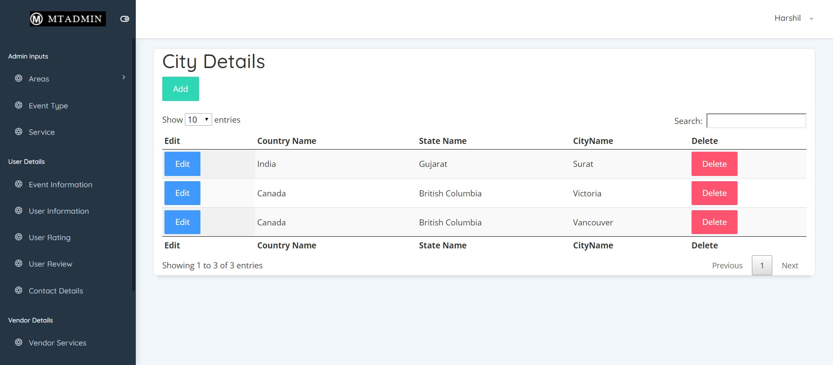

* **Country Details**

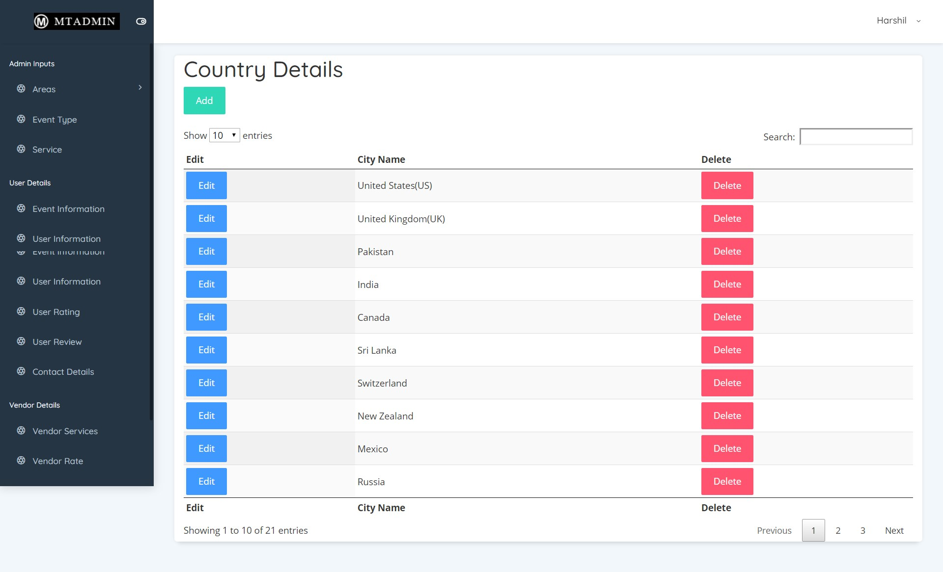

* **State Details**

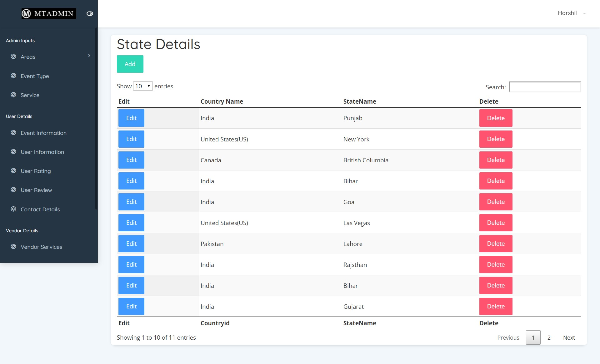

* **User Rating**

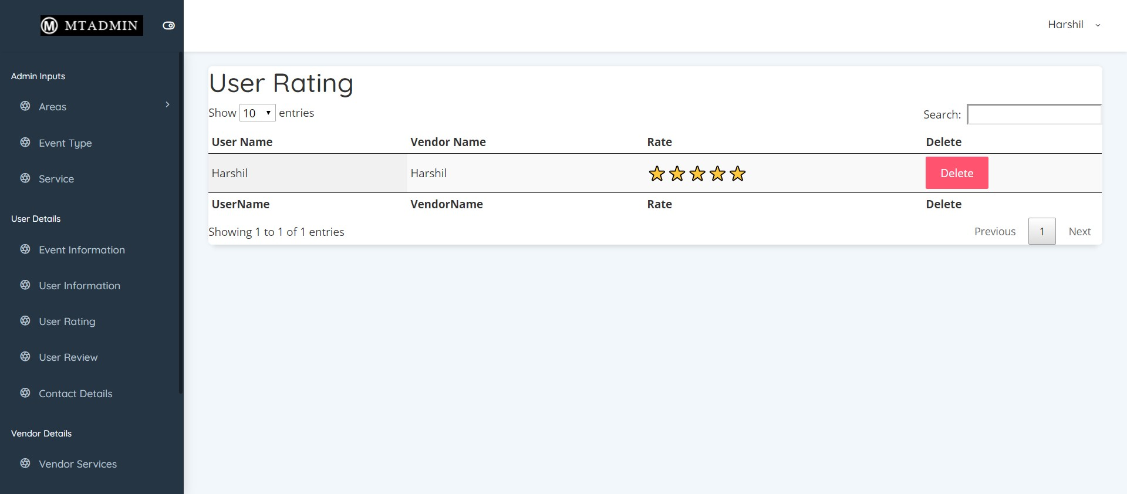

* **Vendor Service**

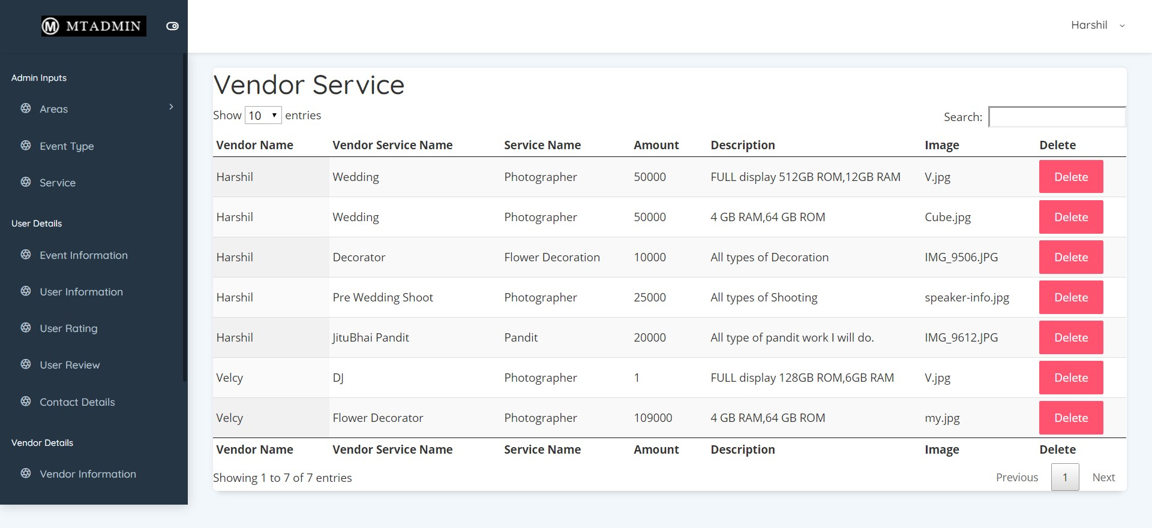

* **Vendor Details**

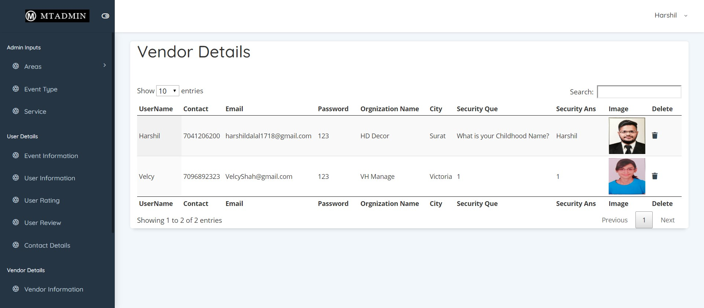

* **Vendor Rating**

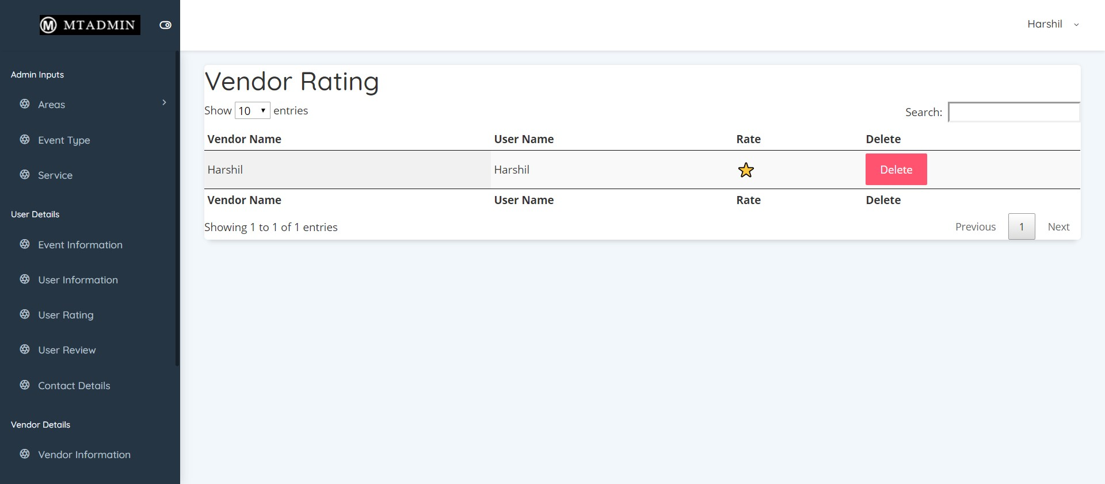

* **Vendor Review**

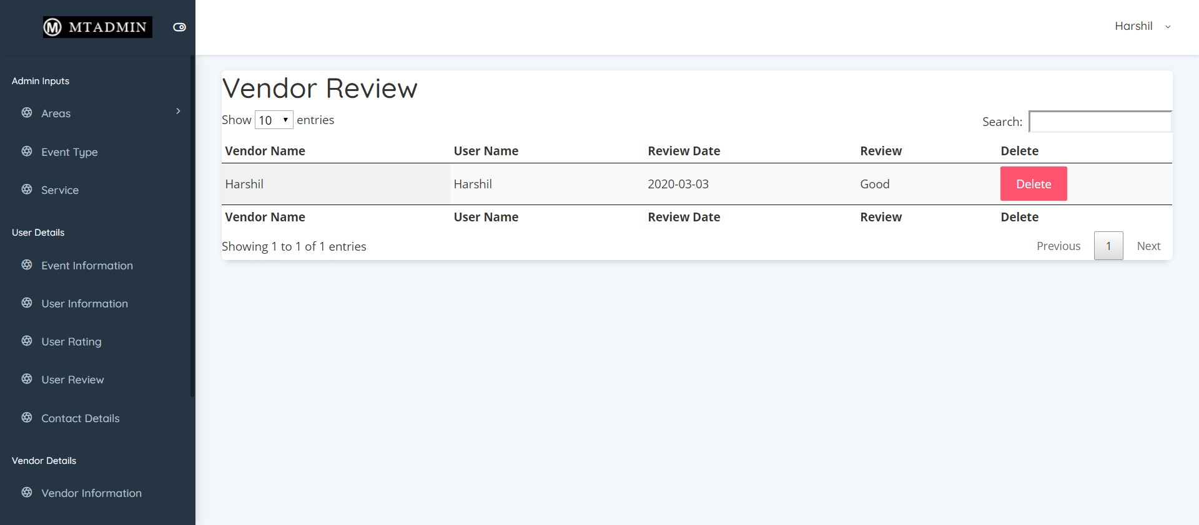

* **Vendor Service Rating**

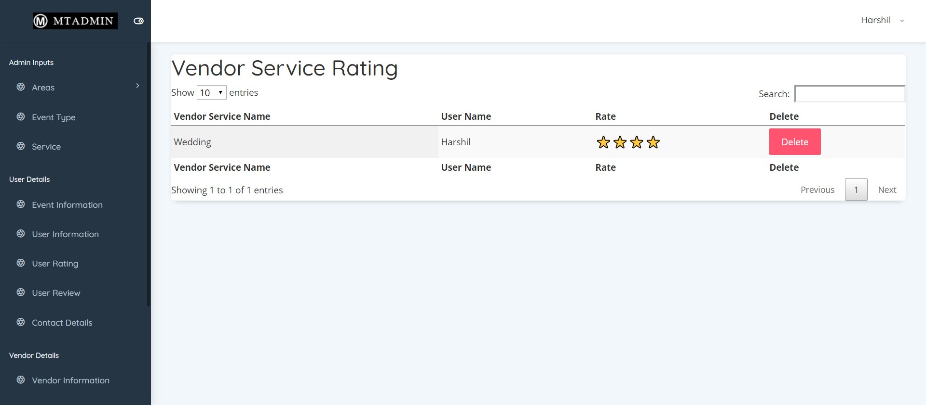

* **Vendor Service Review**

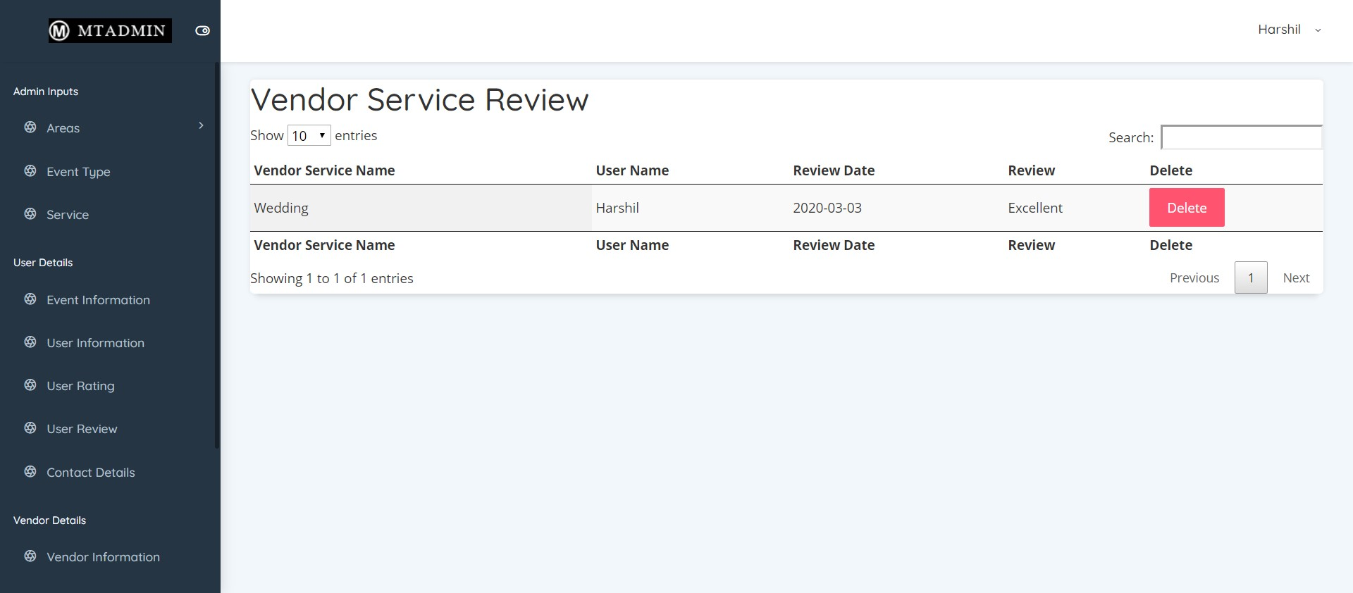

* **Vendor Side**
* **Vendor Login**

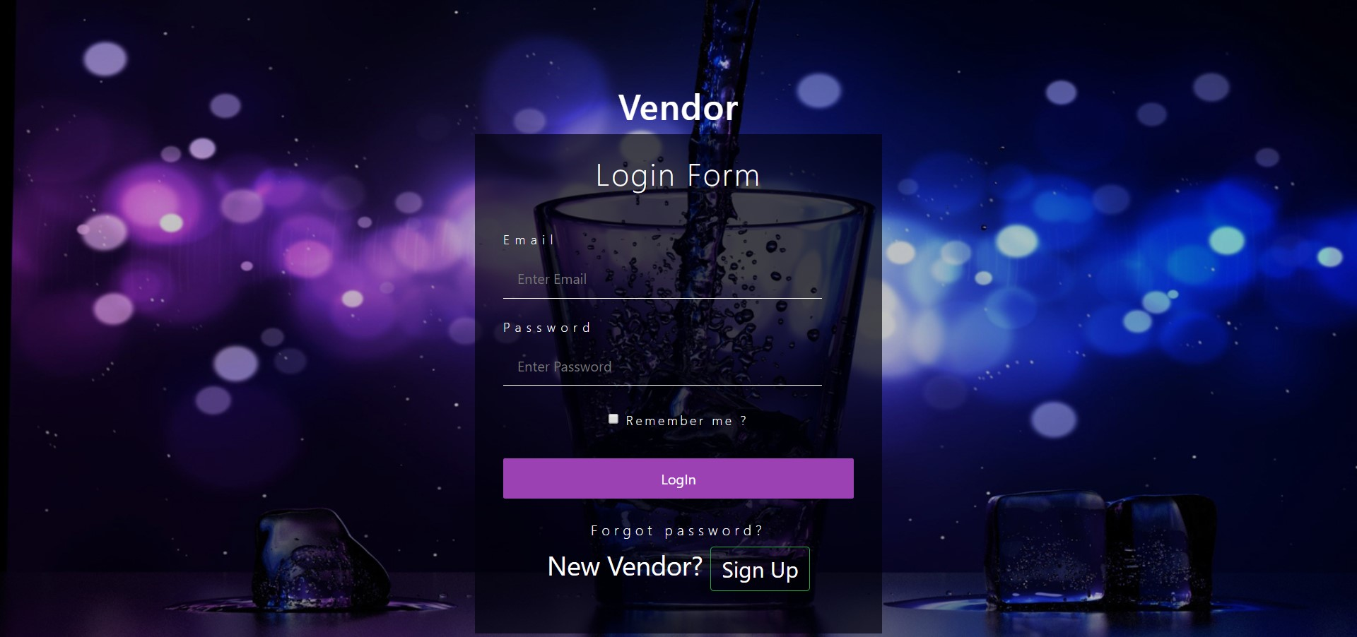

* **Change Password**

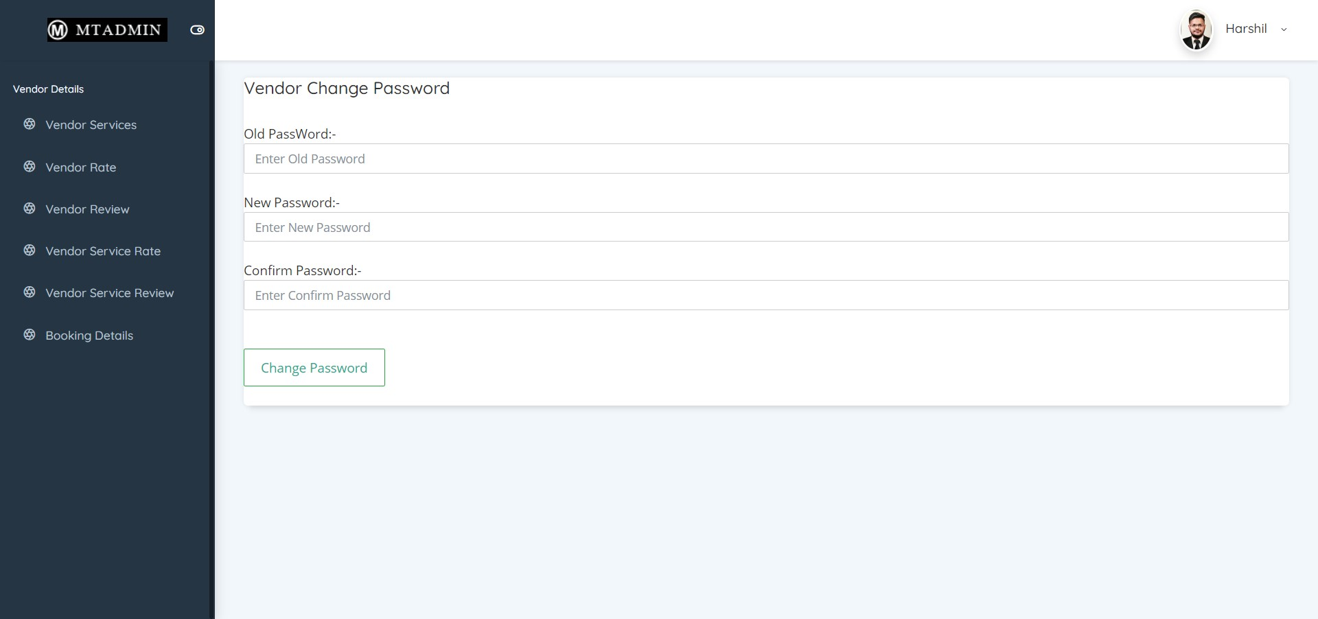

* **Change Password**

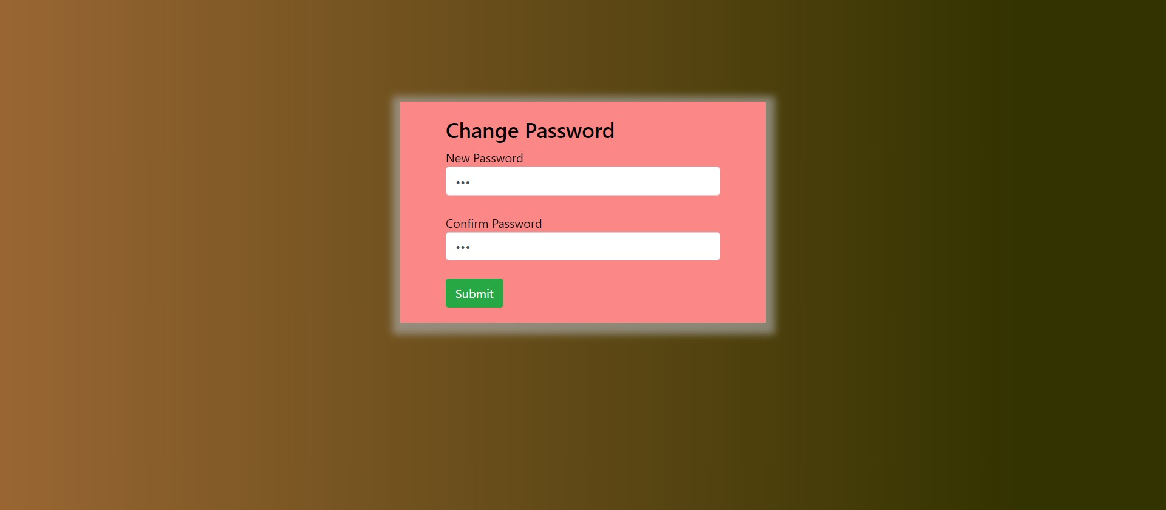

* **Forgot Password**

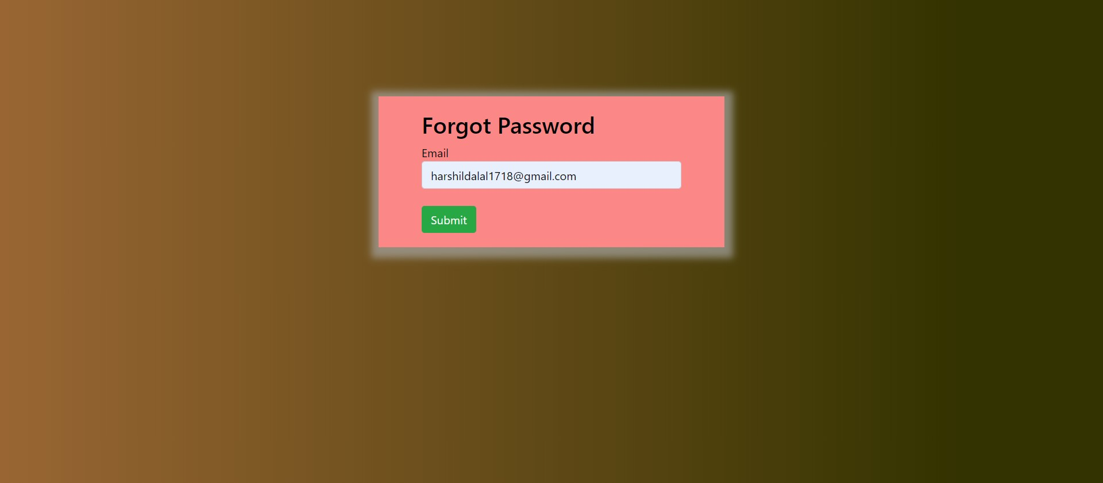

* **Vendor Register**

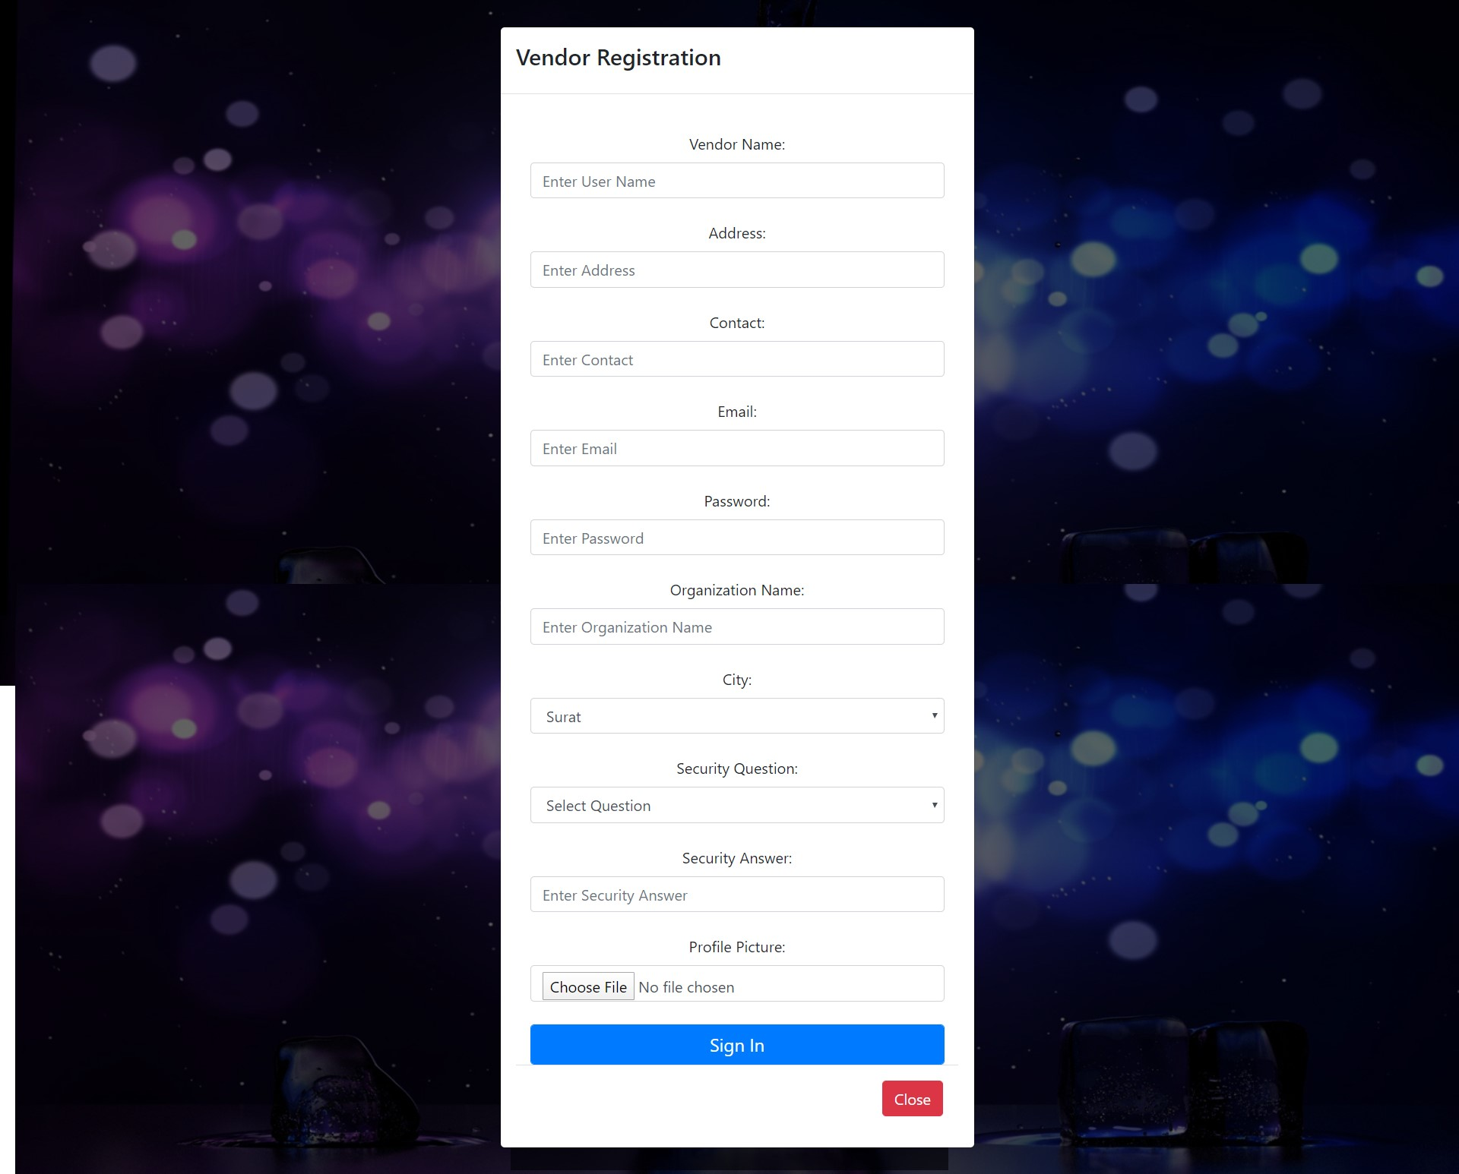

* **Edit Profile**

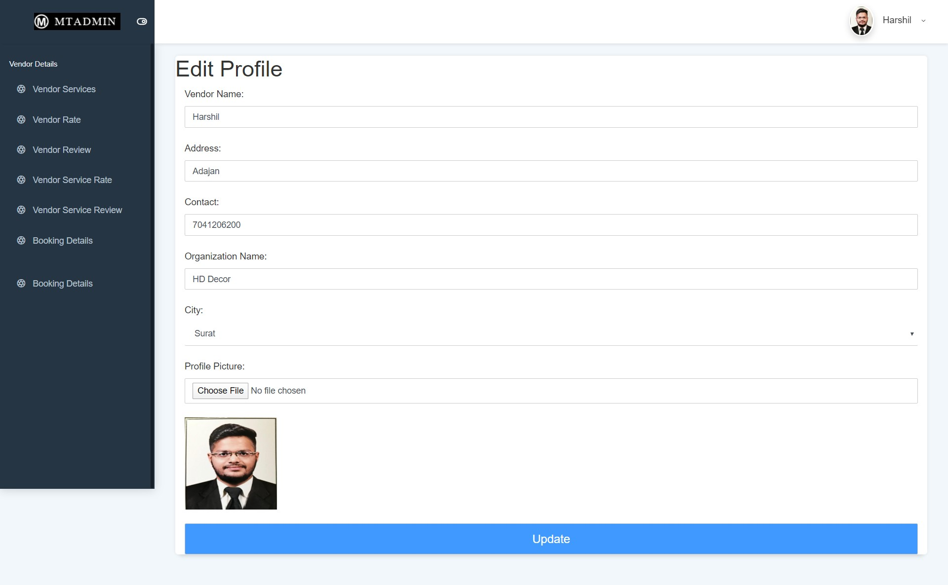

* **Vendor Services**

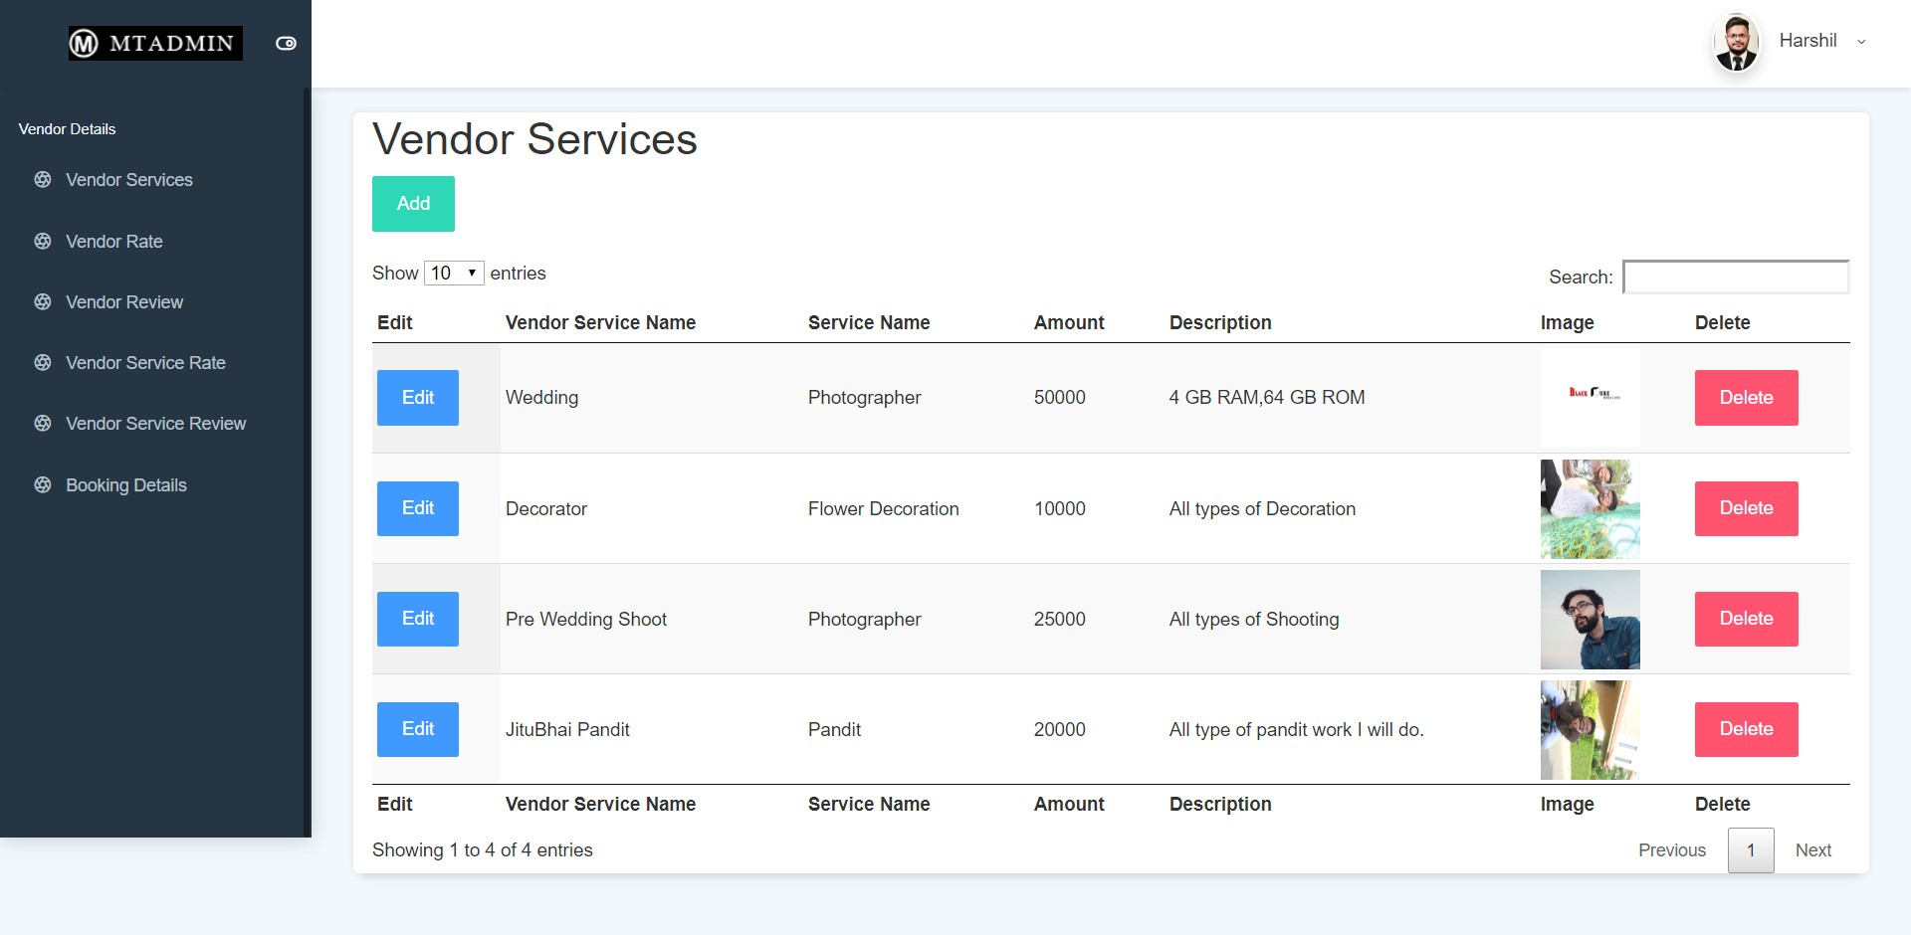

* **Vendor Rating**



* **User Rate & Review**



* **Vendor Review**

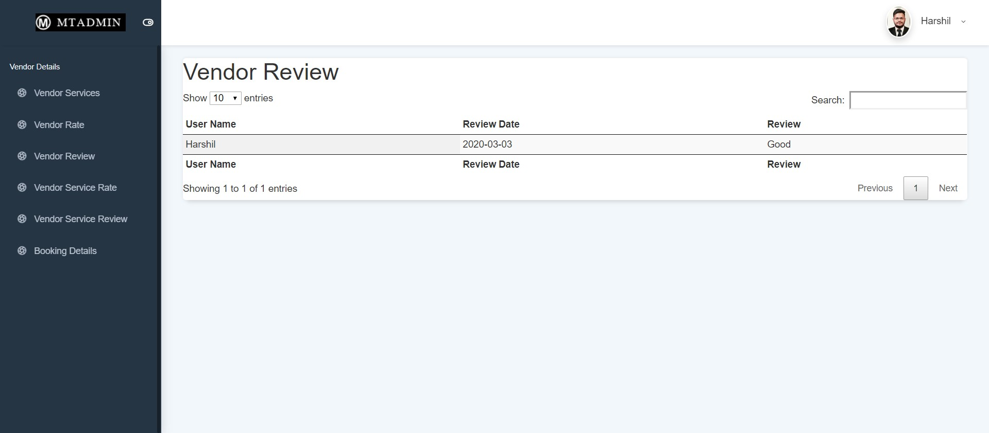

* **Vendor Service Rating**

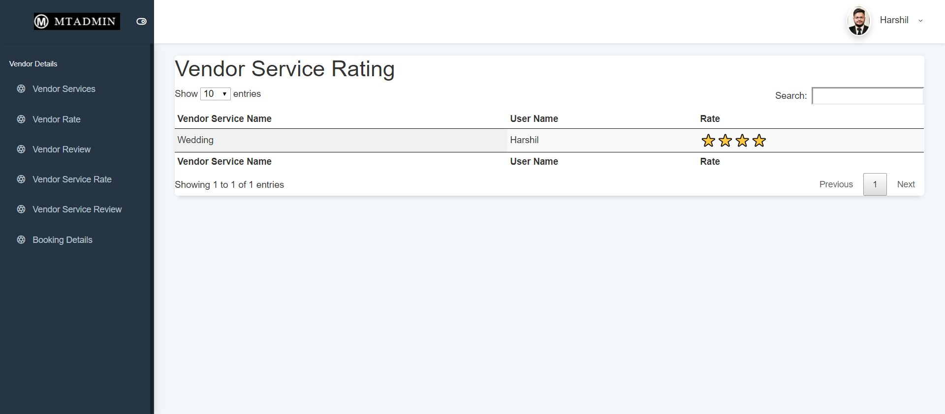

* **Vendor Service Review**

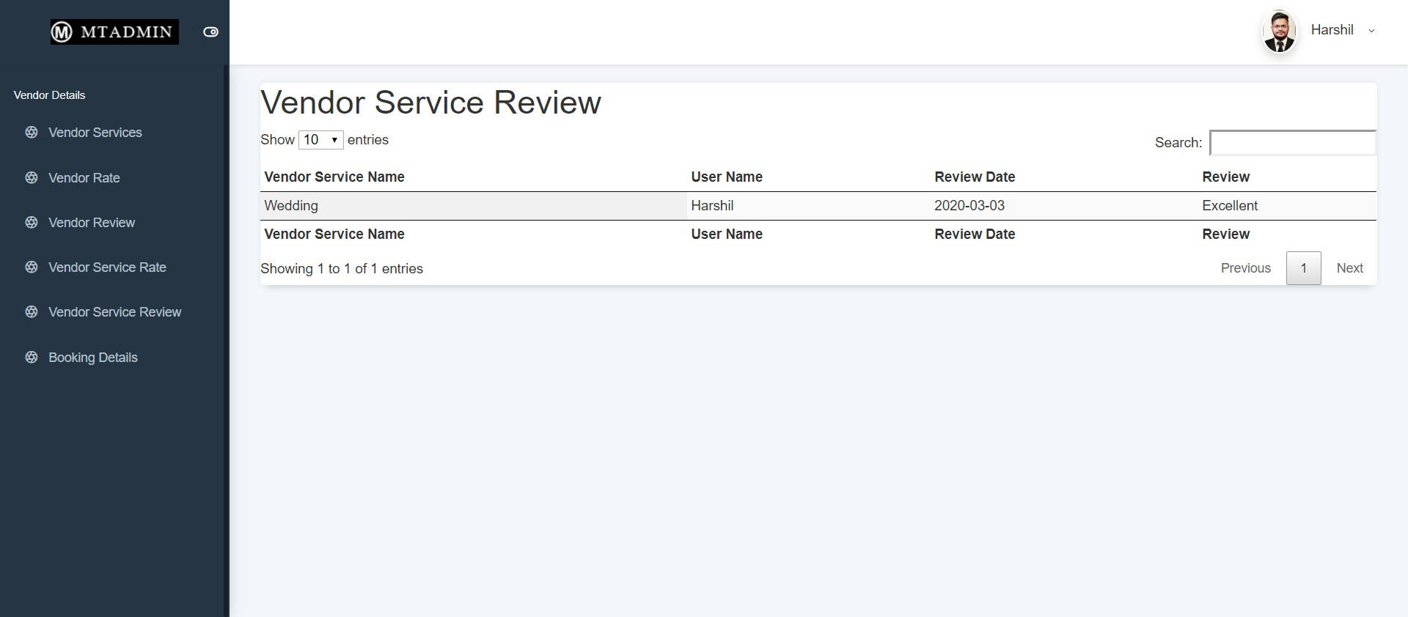

* **Vendor Messanger**





* **User Detail**

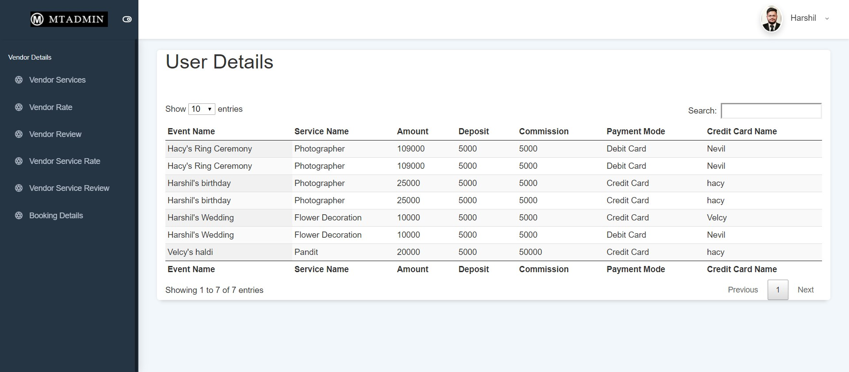

* **6.2 Visitor Side**
* **Visitor – User Login**

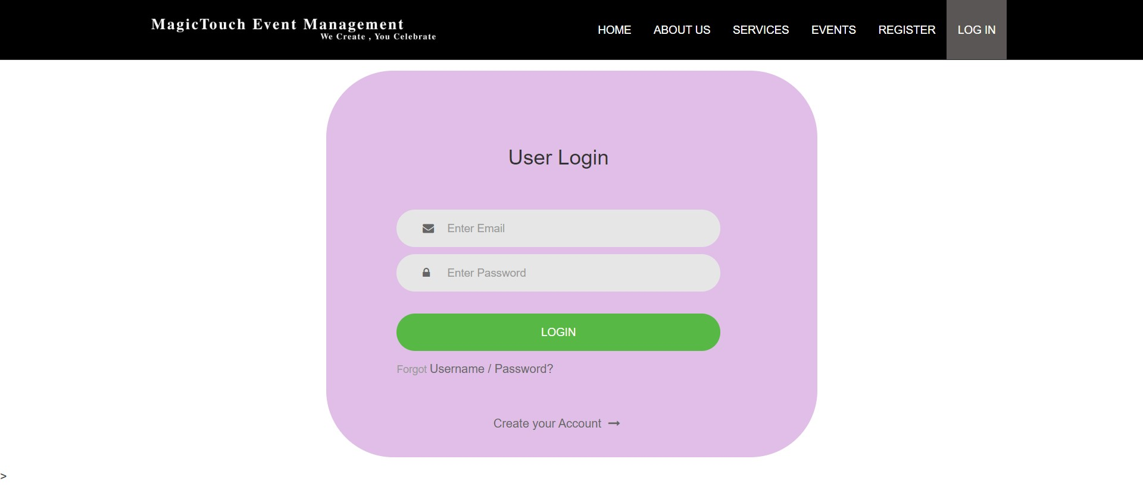

* **Visitor – User Register**

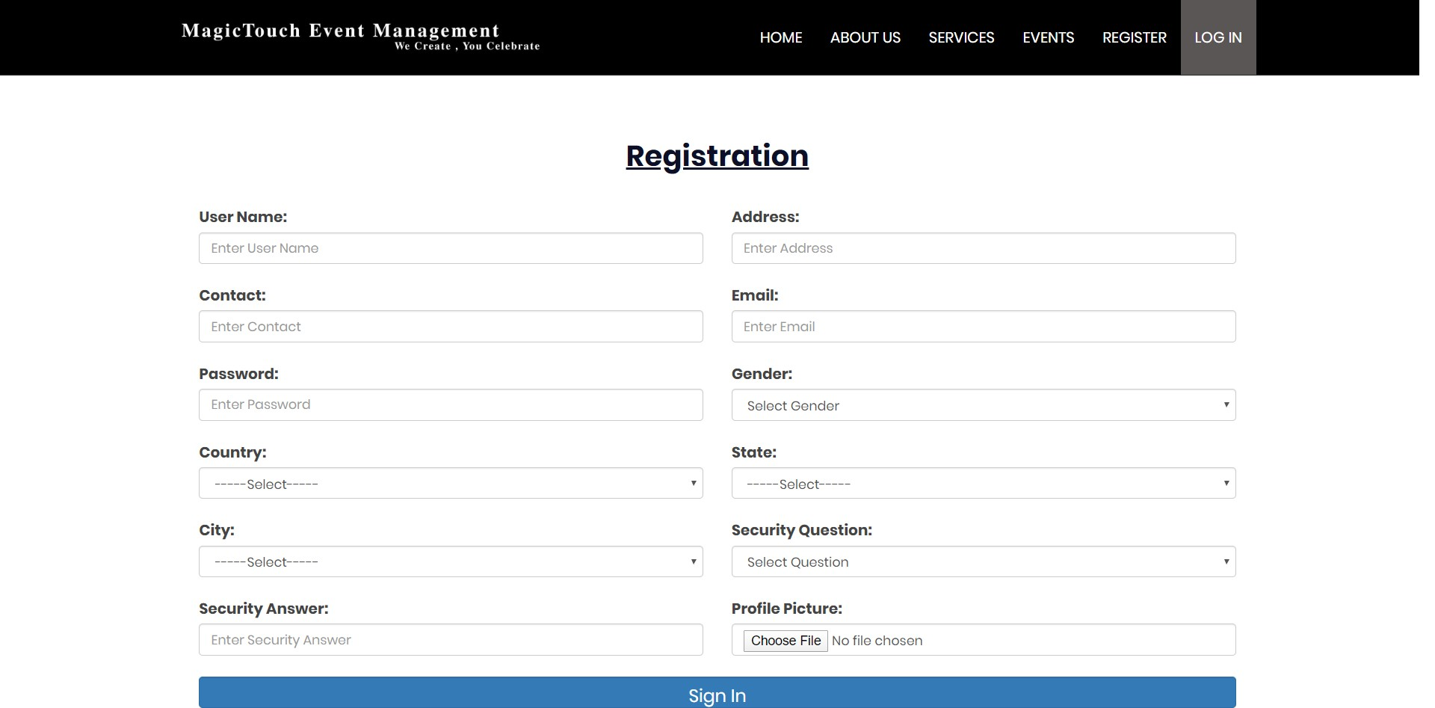

* **Visitor Home**



* **Visitor About Us**

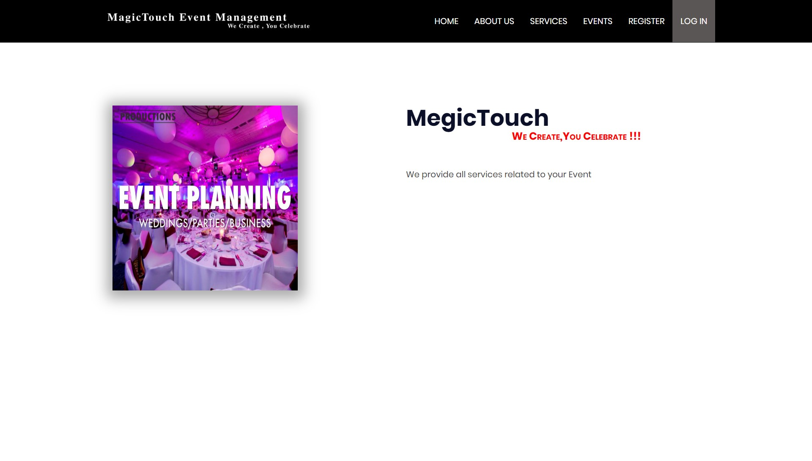

* **Visitor Show Events**

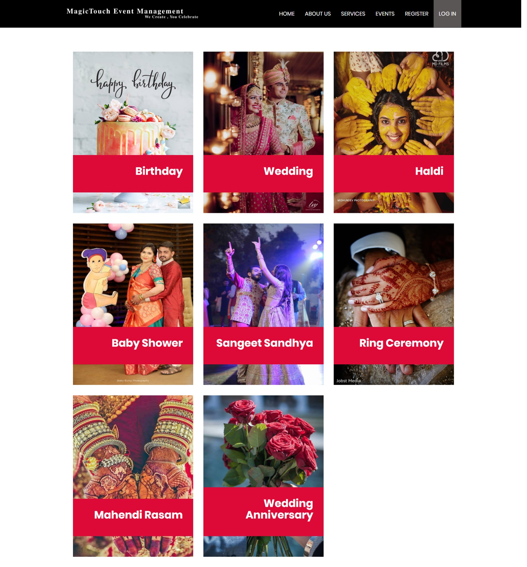

* **Visitor Show Services**

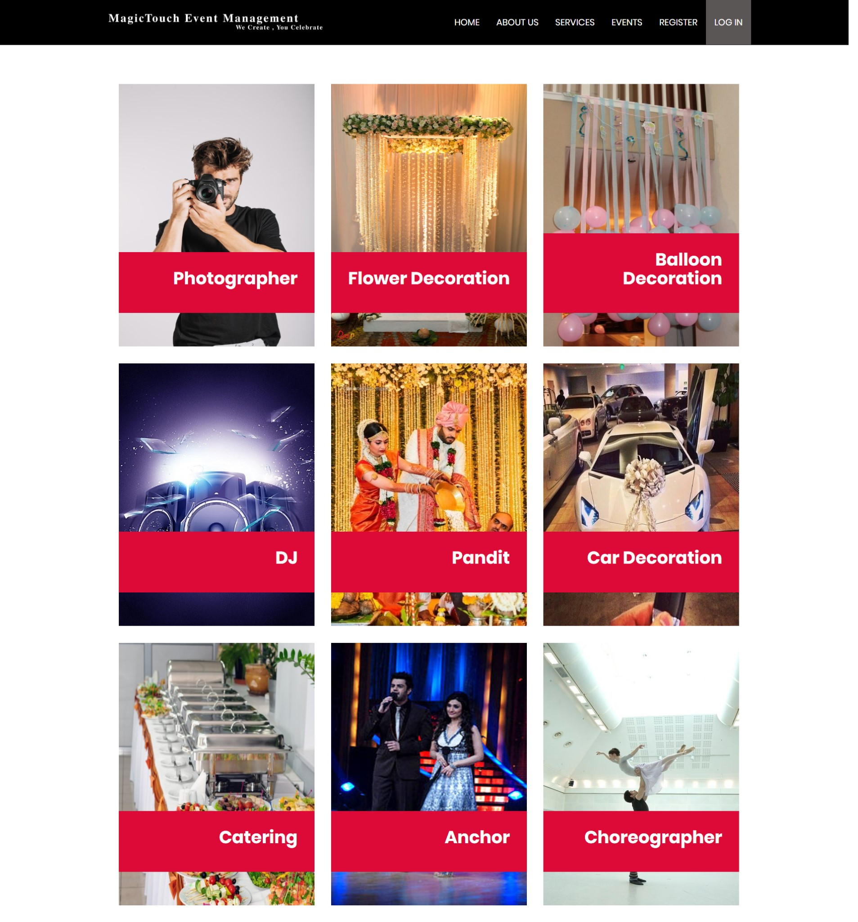

* **Contact Us**

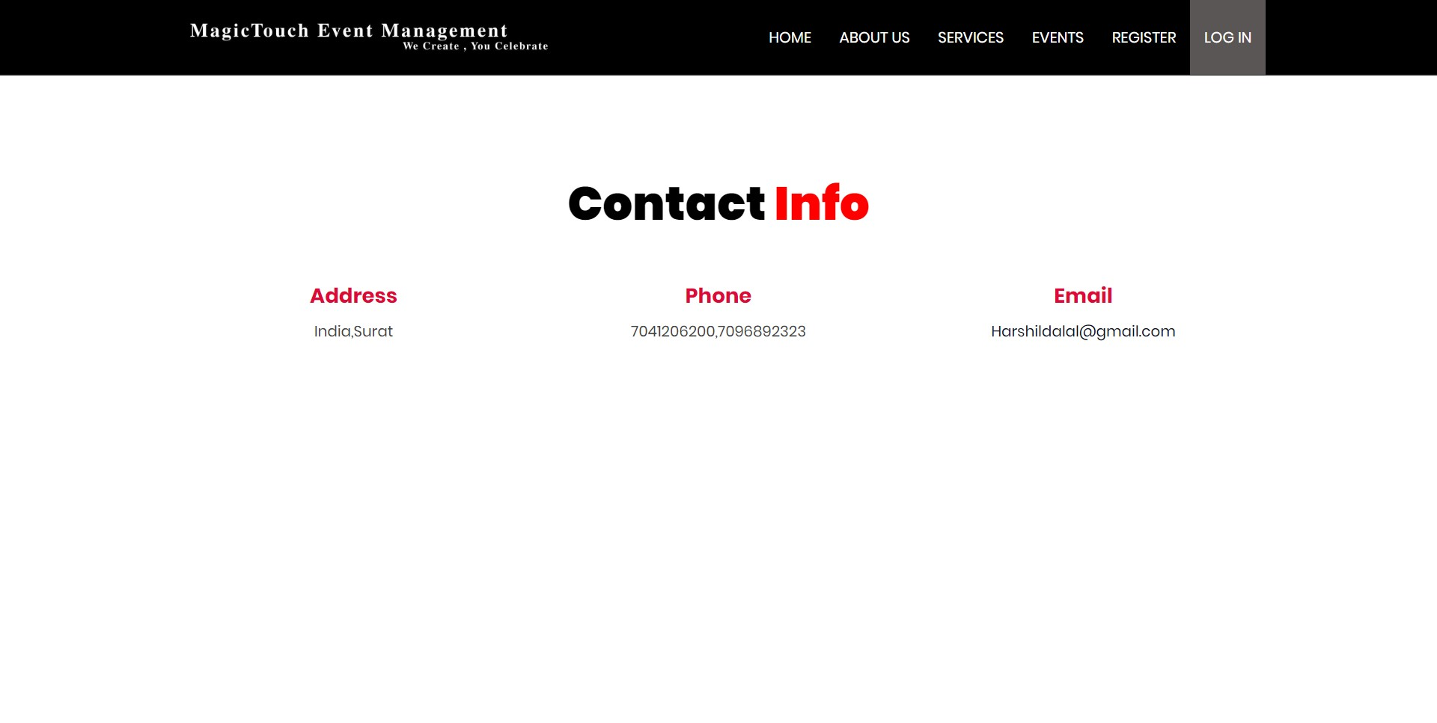

* **Visitor Security Question**

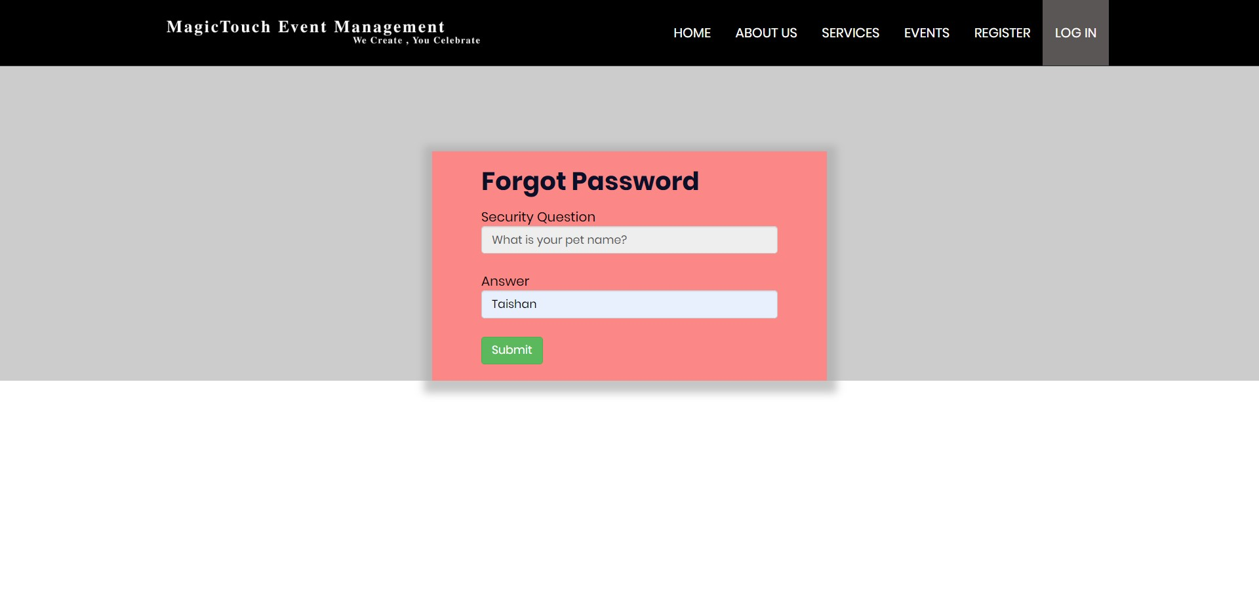

* **Visitor Change Password**

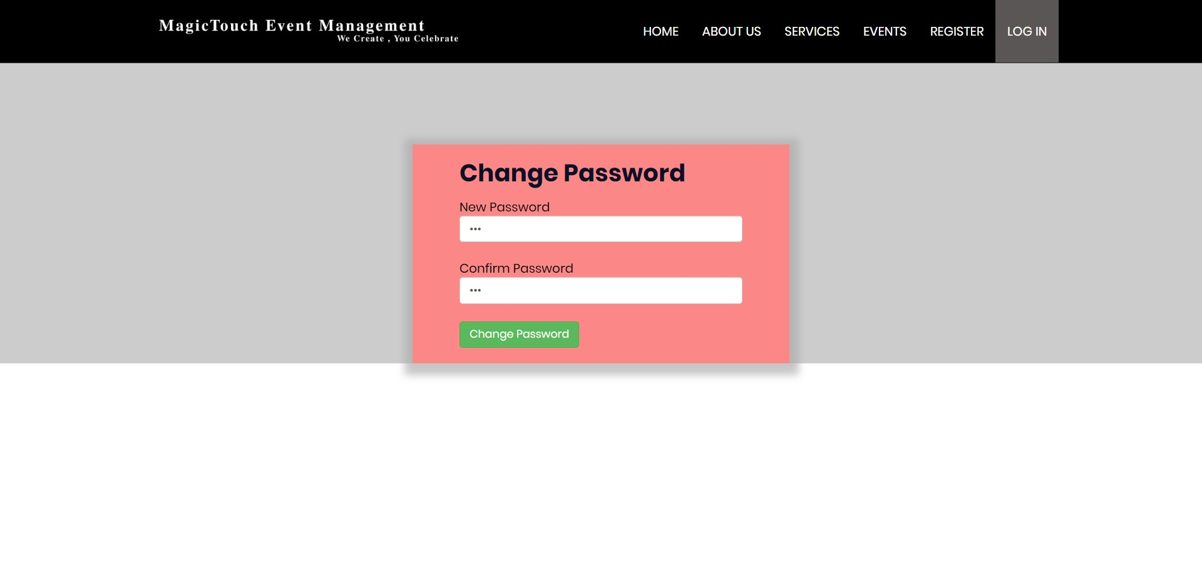

* **Visitor Forgot Password**

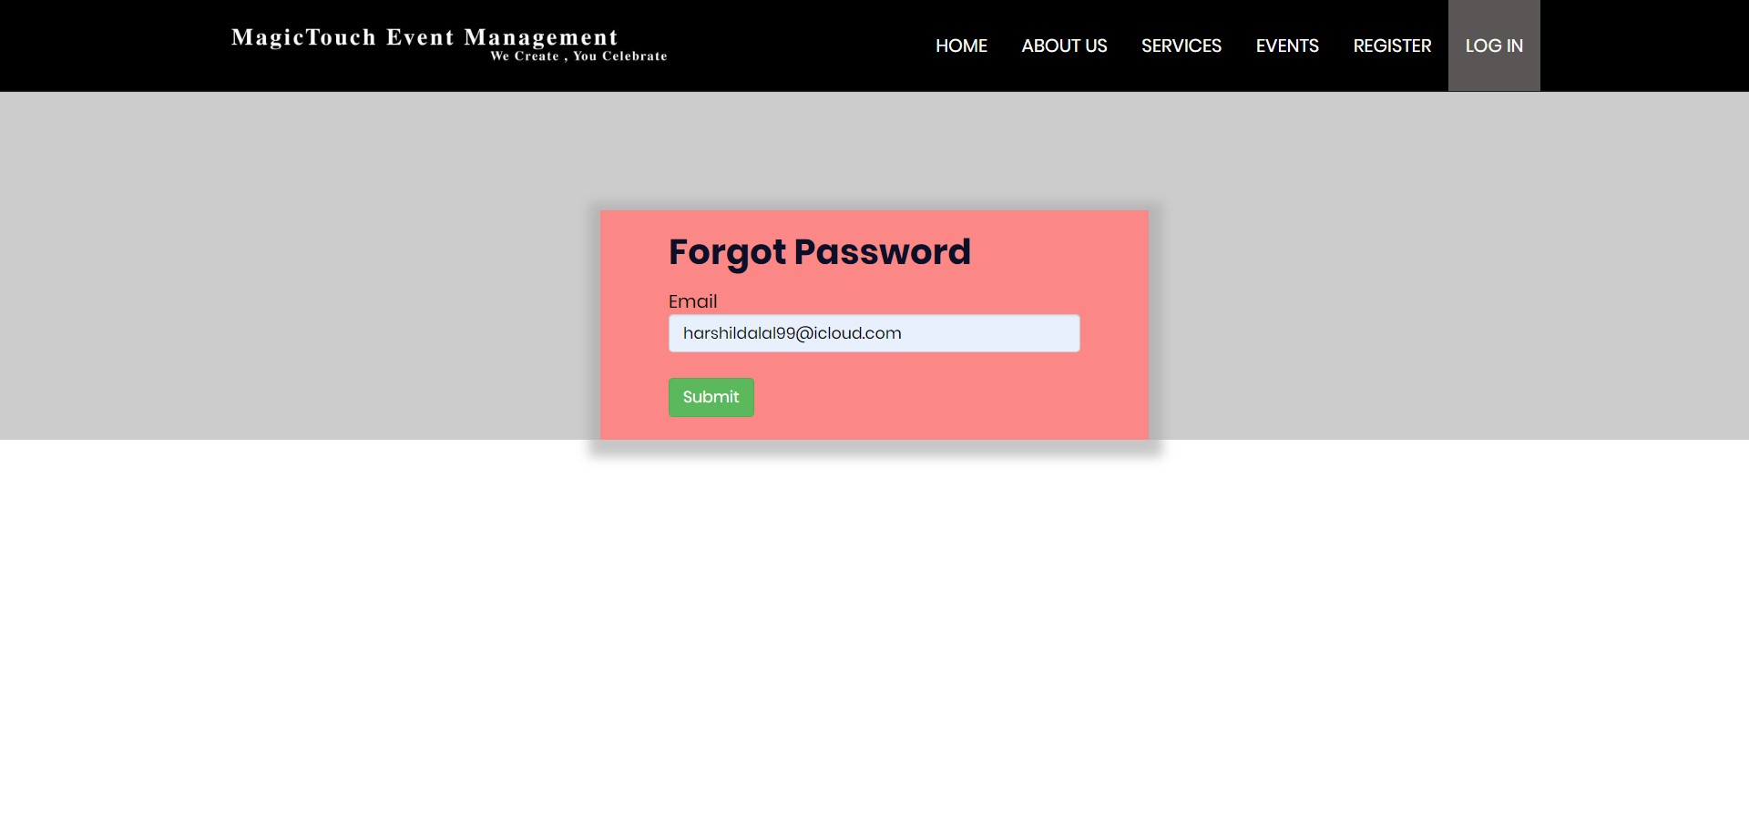

* **User Side**
* **User Home**



* **User Events**

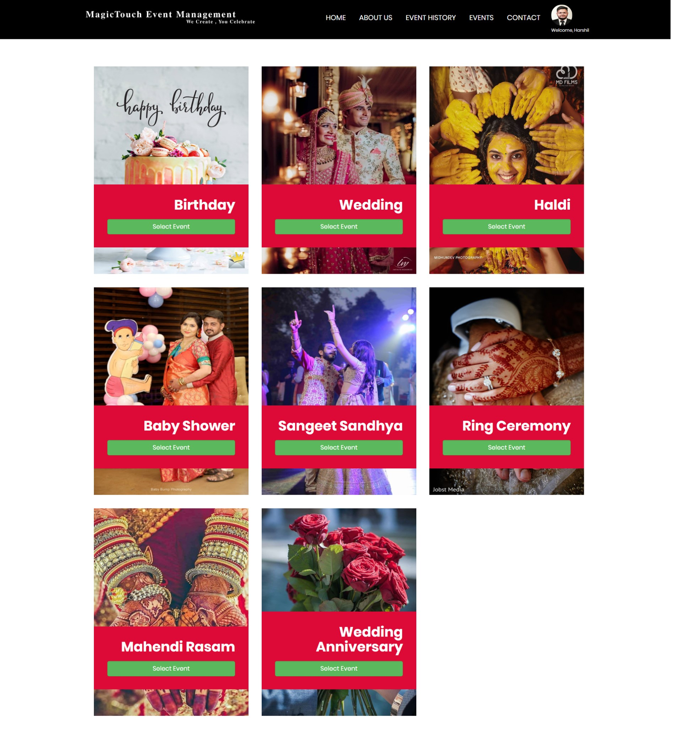

* **User Events Details**

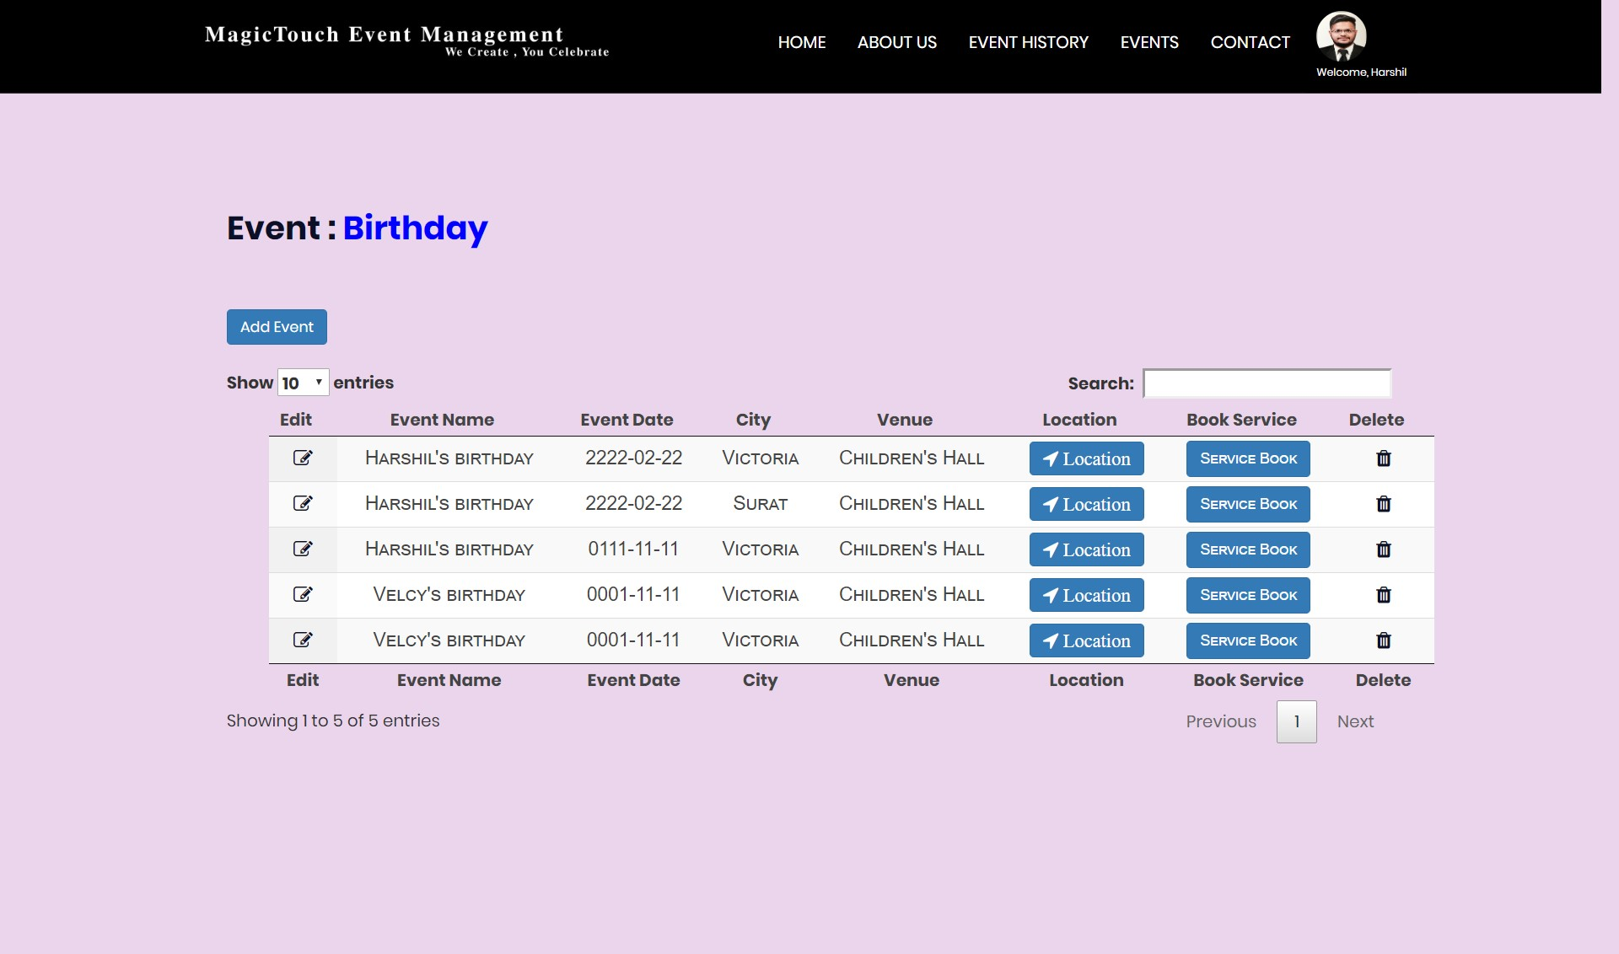

* **Maps**

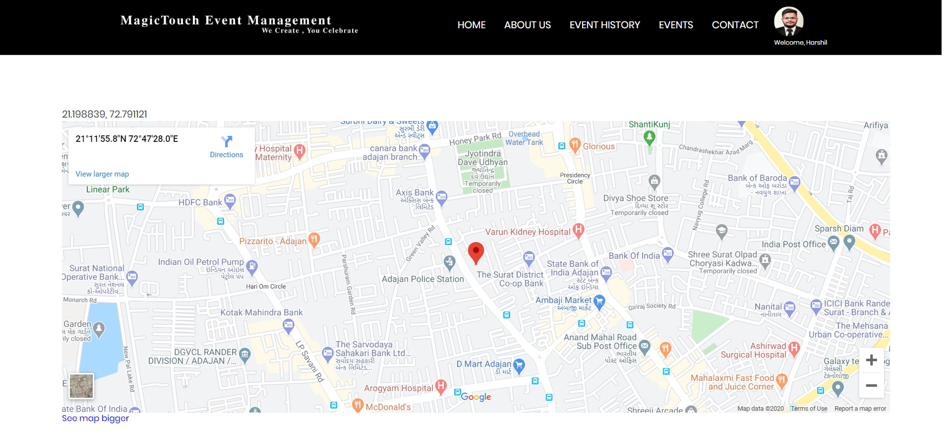

* **User Event Services**

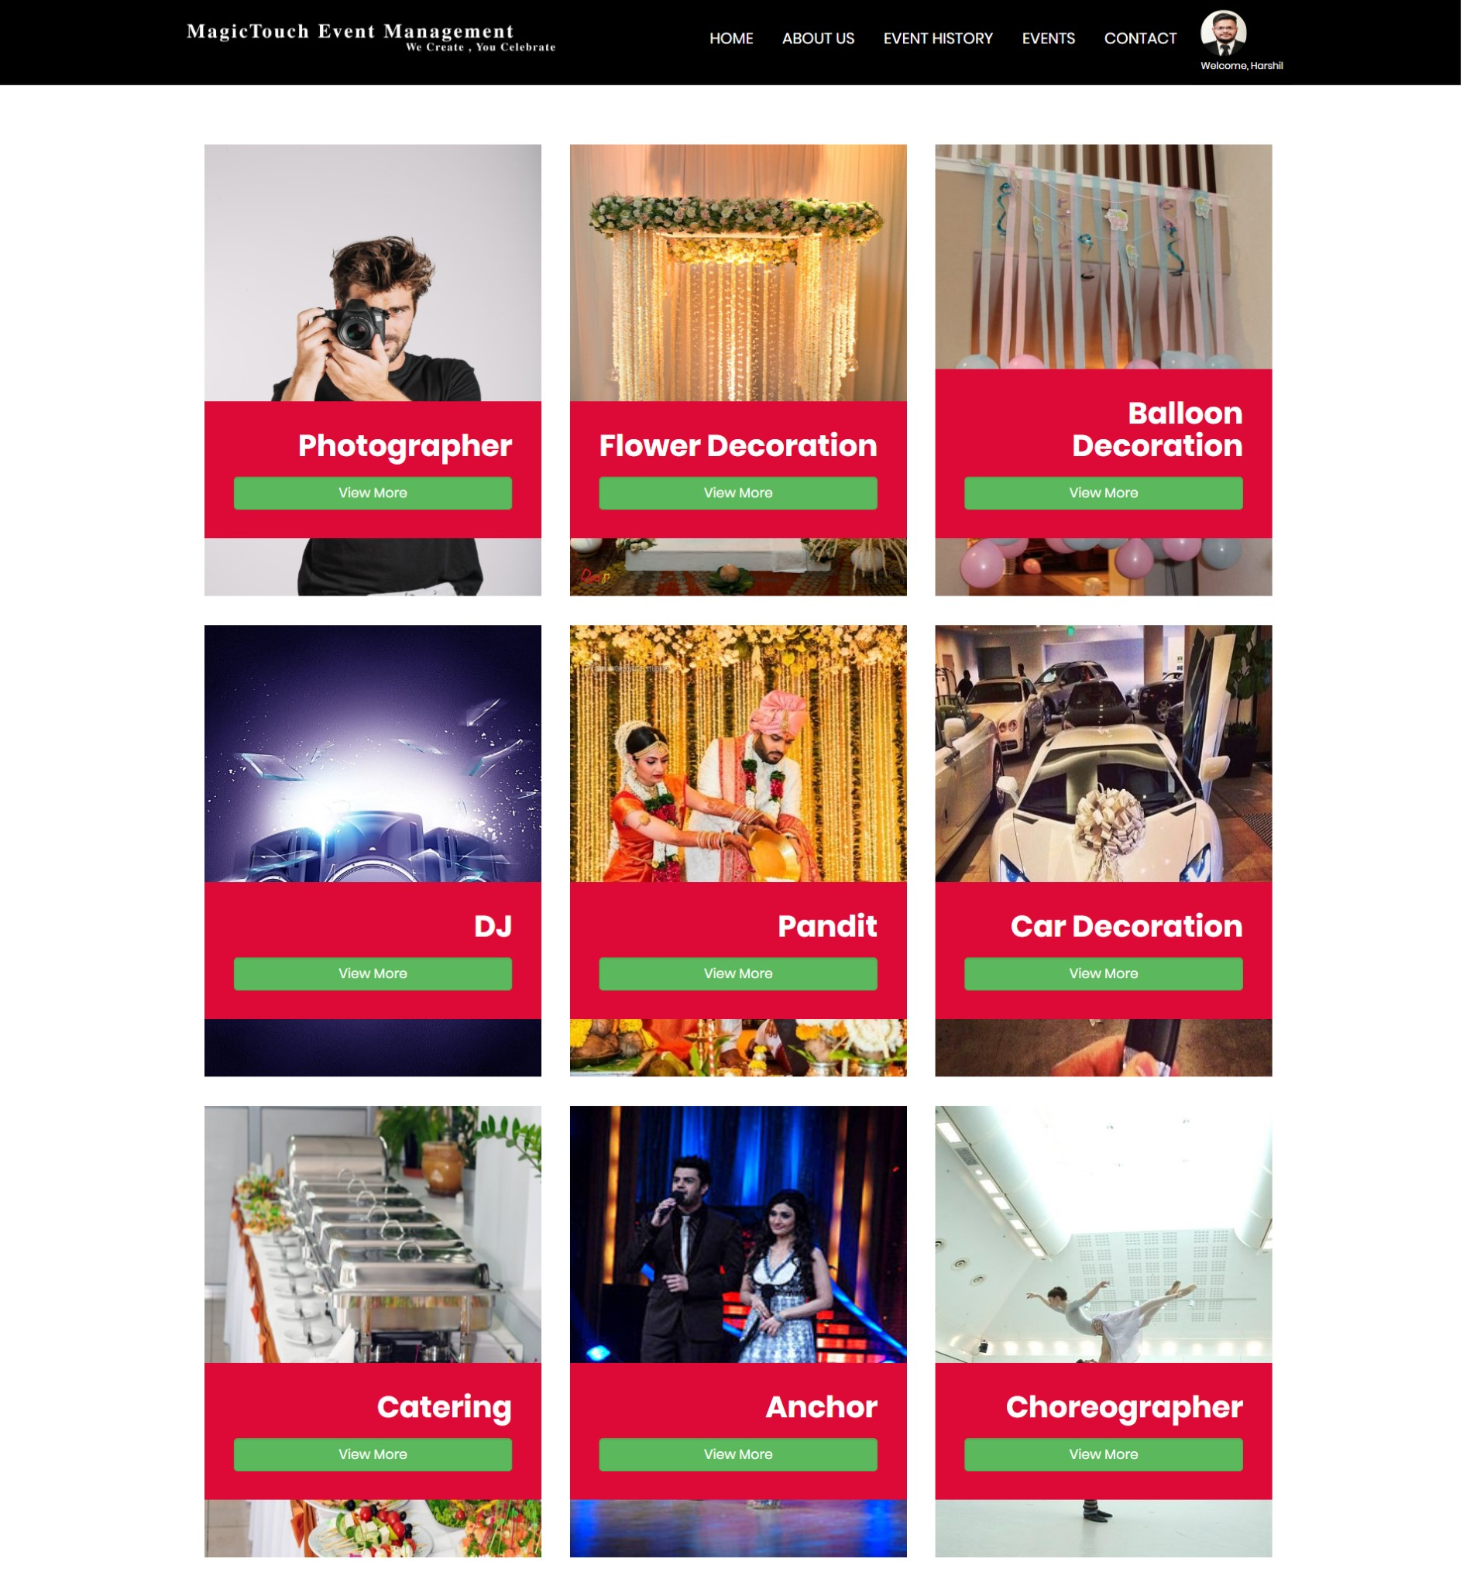

* **Vendor Services**



* **Event History**



* **User Messanger**



* **Vendor Service Rate & Review**



* **Vendor Rate & Review**



* **User Contact**

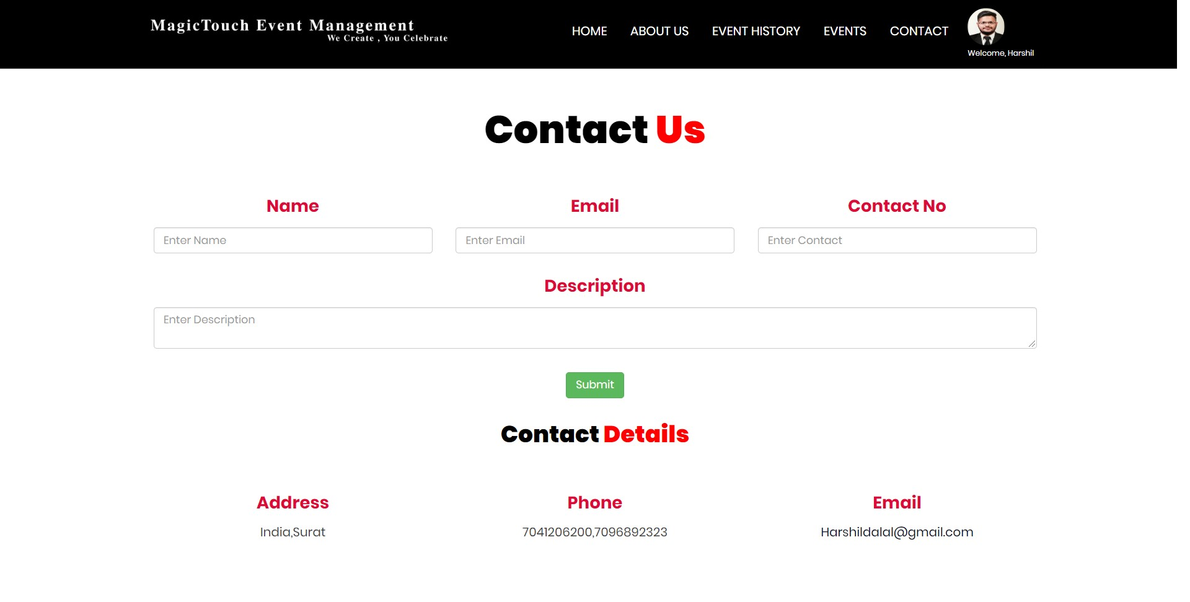

* **User Change Password**

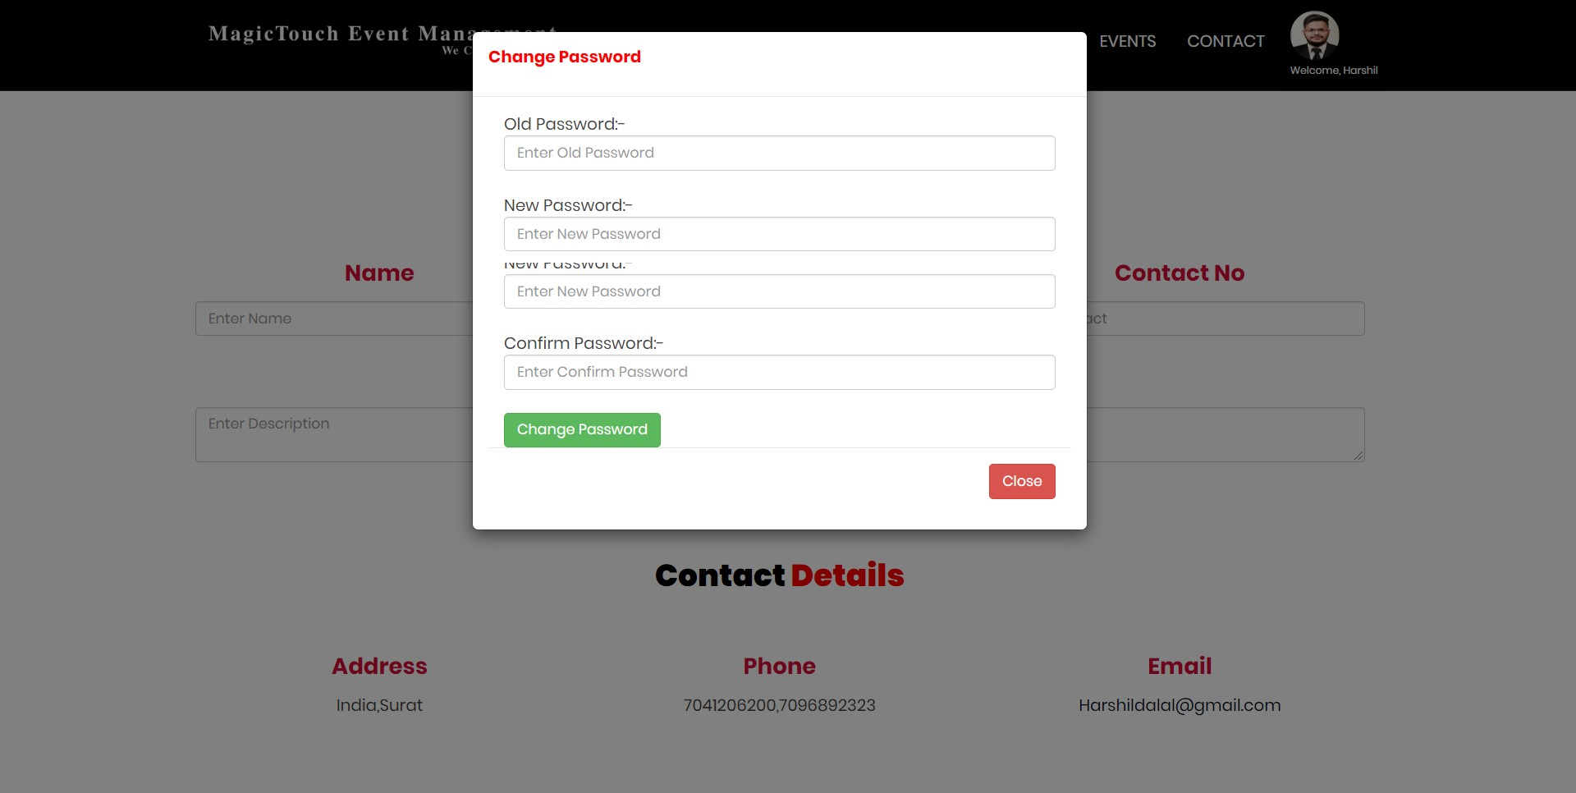

**7. TESTING**

**Software Testing** is an empirical investigation conducted to provide stakeholders with information about the quality of the product or service under test, with respect to the context in which it is intended to operate. Software Testing also provides an objective, independent view of the software to allow the business to appreciate and understand the risks at implementation of the software. Test techniques include, but are not limited to, the process of executing a program or application with the intent of finding software bugs. It can also be stated as the process of validating and verifying that a software program/application/product meets the business and technical requirements that guided its design and development, so that it works as expected and can be implemented with the same characteristics.

Software Testing, depending on the testing method employed, can be implemented at any time in the development process, however the most test effort is employed after the requirements have been defined and coding process has been completed. For not doing break the functionality of existing the system, we will test individual use cases and list down test cases for each of the use case.

**7.1 Unit Testing**

The primary goal of unit testing is to take the smallest piece of testable software in the application, isolate it from the remainder of the code, and determine whether it behaves exactly as you expect. Each unit is tested separately before integrating them into modules to test the interfaces between modules. Unit testing has proven its value in that a large percentage of defects are identified during its use.

**Unit testing** is a software verification and validation method where the programmer gains confidence that individual units of source code are fit for use. A unit is the smallest testable part of an application. In procedural programming a unit may be an individual program, function, procedure, etc., while in object-oriented programming, the smallest unit is a class, which may belong to a base/super class, abstract class or derived/child class.

Ideally, each test case is independent from the others: substitutes like method stubs, mock objects, fakes and test harnesses can be used to assist testing a module in isolation. Unit tests are typically written and run by software developers to ensure that code meets its design and behaves as intended. Its implementation can vary from being very manual (pencil and paper) to being formalized as part of build automation.

**7.2 Integration Testing**

Integration testing, also known as integration and testing (I&T), is a software development process which program units are combined and tested as groups in multiple ways. In this context, a unit is defined as the smallest testable part of an application. Integration testing can expose problems with the interfaces among program components before trouble occurs in real-world program execution. Integration testing is a component of Extreme Programming (XP), a pragmatic method of software development that takes a meticulous approach to building a product by means of continual testing and revision.

There are two major ways of carrying out an integration test, called the bottom-up method and the top-down method. Bottom-up integration testing begins with unit testing, followed by tests of progressively higher-level combinations of units called modules or builds. In top-down integration testing, the highest-level modules are tested first and progressively lower-level modules are tested after that. In a comprehensive software development environment, bottom-up testing is usually done first, followed by top-down testing.

**7.3 Validation testing**:

At the validation level, testing focuses on user visible actions and user recognizable output from the system. Validations testing is said to be successful when software functions in a manner that can be reasonably expected by the customer. Two types of validation testing.

• **Alpha testing** is simulated or actual operational testing by potential users/customers or an independent test team at the developers' site. Alpha testing is often employed for off-the-shelf software as a form of internal acceptance testing, before the software goes to beta testing.

• **Beta testing** comes after alpha testing. Versions of the software, known as beta version, are released to a limited audience outside of the programming team. The software is released to groups of people so that further testing can ensure the product has few faults or bugs. Sometimes, beta versions are made available to the open public to increase the feedback field to a maximal number of future users

• **Grey box testing** Grey box testing is the combination of black box and white box testing. Intention of this testing is to find out defects related to bad design or bad implementation of the system.it is used for web application

* **Login (Vendor , User)**

|  |  |  |  |  |  |
| --- | --- | --- | --- | --- | --- |
| **Test Case NO.** | **Test Cases** | **Data Type** | **Conditions** | **Error Messages** | **Actual Results**  **(Pass / Fail)** |
| 1 | Email | Varchar | Check whether Email is correct or not | Generate appropriate error message | Pass |
| 2 | Password | Varchar | Check whether Password is correct or not | Generate appropriate error message | Pass |

* **Registration**

|  |  |  |  |  |  |
| --- | --- | --- | --- | --- | --- |
| **Test Case NO.** | **Test Cases** | **Data Type** | **Conditions** | **Error Messages** | **Actual Results**  **(Pass / Fail)** |
| 1 | VendorName | Varchar | Check whether VendorName is correct or not | Generate appropriate error message | Pass |
| 2 | Address | Varchar | Check whether Address is correct or not | Generate appropriate error message | Pass |
| 3 | Contact | Varchar | Check whether Contact is correct or not | Generate appropriate error message | Pass |
| 4 | Email | Varchar | Check whether Email is correct or not | Generate appropriate error message | Pass |
| 5 | Password | Varchar | Check whether Password is correct or not | Generate appropriate error message | Pass |
| 6 | Security Qes | Varchar | Check whether Security Qes is correct or not | Generate appropriate error message | Pass |
| 7 | Security Ans | Varchar | Check whether Security Ans is correct or not | Generate appropriate error message | Pass |
| 8 | UserName | Varchar | Check whether UserName is correct or not | Generate appropriate error message | Pass |

* **EventType**

|  |  |  |  |  |  |
| --- | --- | --- | --- | --- | --- |
| **Test Case NO.** | **Test Cases** | **Data Type** | **Conditions** | **Error Messages** | **Actual Results**  **(Pass / Fail)** |
| 1 | EventTypeid | Numeric | Check whether EventTypeid is correct or not | Generate appropriate error message | Pass |
| 2 | EventType Name | Varchar | Check whether EventTypeName is correct or not | Generate appropriate error message | Pass |
| 3 | Image | Varchar | Check whether Image is correct or not | Generate appropriate error message | Pass |

* **Event**

|  |  |  |  |  |  |
| --- | --- | --- | --- | --- | --- |
| **Test Case NO.** | **Test Cases** | **Data Type** | **Conditions** | **Error Messages** | **Actual Results**  **(Pass / Fail)** |
| 1 | EventName | Varchar | Check whether EventName is correct or not | Generate appropriate error message | Pass |
| 2 | EventDate | Varchar | Check whether EventDate is correct or not | Generate appropriate error message | Pass |
| 3 | Venue | Varchar | Check whether Venue is correct or not | Generate appropriate error message | Pass |
| 4 | Location | Varchar | Check whether Location is correct or not | Generate appropriate error message | Pass |

* **Country**

|  |  |  |  |  |  |
| --- | --- | --- | --- | --- | --- |
| **Test Case NO.** | **Test Cases** | **Data Type** | **Conditions** | **Error Messages** | **Actual Results**  **(Pass / Fail)** |
| 1 | Countryid | Numeric | Check whether Countryid is correct or not | Generate appropriate error message | Pass |
| 2 | CountryName | Varchar | Check whether CountryName is correct or not | Generate appropriate error message | Pass |

* **State**

|  |  |  |  |  |  |
| --- | --- | --- | --- | --- | --- |
| **Test Case NO.** | **Test Cases** | **Data Type** | **Conditions** | **Error Messages** | **Actual Results**  **(Pass / Fail)** |
| 1 | Stateid | Numeric | Check whether Stateid is correct or not | Generate appropriate error message | Pass |
| 2 | Countryid | Numeric | Check whether Countryid is correct or not | Generate appropriate error message | Pass |
| 3 | StateName | Varchar | Check whether StateName is correct or not | Generate appropriate error message | Pass |

* **City**

|  |  |  |  |  |  |
| --- | --- | --- | --- | --- | --- |
| **Test Case NO.** | **Test Cases** | **Data Type** | **Conditions** | **Error Messages** | **Actual Results**  **(Pass / Fail)** |
| 1 | Cityid | Numeric | Check whether Cityid is correct or not | Generate appropriate error message | Pass |
| 2 | Stateid | Numeric | Check whether Stateid is correct or not | Generate appropriate error message | Pass |
| 3 | CityName | Varchar | Check whether CityName is correct or not | Generate appropriate error message | Pass |

* **VendorService**

|  |  |  |  |  |  |
| --- | --- | --- | --- | --- | --- |
| **Test Case NO.** | **Test Cases** | **Data Type** | **Conditions** | **Error Messages** | **Actual Results**  **(Pass / Fail)** |
| 1 | VendorServiceid | Numeric | Check whether VendorServiceid is correct or not | Generate appropriate error message | Pass |
| 2 | Vendorid | Numeric | Check whether Vendorid is correct or not | Generate appropriate error message | Pass |
| 3 | VendorService Name | Varchar | Check whether VendorService Name is correct or not | Generate appropriate error message | Pass |
| 4 | Serviceid | Numeric | Check whether  Serviceid is correct or not | Generate appropriate error message | Pass |
| 5 | Amount | Numeric | Check whether Amount is correct or not | Generate appropriate error message | Pass |
| 6 | Description | Varchar | Check whether Description is correct or not | Generate appropriate error message | Pass |
| 7 | Image | Varchar | Check whether Image is correct or not | Generate appropriate error message | Pass |

* **ServiceBook**

|  |  |  |  |  |  |
| --- | --- | --- | --- | --- | --- |
| **Test Case NO.** | **Test Cases** | **Data Type** | **Conditions** | **Error Messages** | **Actual Results**  **(Pass / Fail)** |
| 1 | Bookid | Numeric | Check whether Bookid is correct or not | Generate appropriate error message | Pass |
| 2 | Eventid | Numeric | Check whether Eventid is correct or not | Generate appropriate error message | Pass |
| 3 | Amount | Numeric | Check whether Amount is correct or not | Generate appropriate error message | Pass |
| 4 | Deposit | Numeric | Check whether Deposit is correct or not | Generate appropriate error message | Pass |
| 5 | Commission | Numeric | Check whether Commission is correct or not | Generate appropriate error message | Pass |
| 6 | PaymentMode | Numeric | Check whether Payment Mode is correct or not | Generate appropriate error message | Pass |

**8. Limitation Of System**

**DISADVANTAGES:**

* Lot of paper work required.
* Man power was more.
* Time consuming process.

**9. Future Enhancement**

In this application we can provide multiple functionality, hence due to lack of time as well less knowledge.

I cannot do that. We can provide functionality like User can choice his event place as restaurants as well as choices their meal packages also user can custom their meal packages. In short we can use hotel management system in this project.

Even we can make it more accruable.

**10. Conclusion**

Our project is only a humble venture to satisfy the needs to manage their project work. Several user friendly coding have also adopted. This package shall prove to be a powerful package in satisfy all requirements of the user. The objective of software planning is to provide a frame work that enable the manager to make reasonable estimate made within a limited time frame at the beginning of the software project and should be update regularly as the project regularly.

At the end it is concluded that we have made effort on following points…

A description of background and context of the project and its relation to work already done in the area.

Made statement of the aims and objectives of the project.

The description of the purpose, scope and applicability.

We define the project on which we are working in project.

We describe the requirement specifications of the system and actions that can be done on these things.

We designed user interface and security issues related to system.

Finally the system is implemented and tested according to the test cases.

**11. References**

<http://www.slideshare.net/DYogendraRao/event-management-system-24592836>

<http://www.slideshare.net/FNISHA/online-event-mngmnt-system>

**Other References**

1. <http://www.w3schools.com/>

2.<http://stackoverflow.com/>

3. <https://www.tutorialspoint.com/web_development_tutorials.htm>

4.<http://github.com/>

5. <http://www.vogella.com/tutorials/dotnet/artcle.html>